UNITED STATES
SECURITIES AND EXCHANGE COMMISSION
Washington, D.C. 20549
SCHEDULE 14A
(RULE 14a-101)
SCHEDULE 14A INFORMATION
Proxy Statement Pursuant to Section 14(a) of the
Securities Exchange Act of 1934
Filed by the Registrant ☒ Filed by a Party other than the Registrant ☐
Check the appropriate box:
Carlyle Secured Lending, Inc.
☐
☐
☒
☐

☐
Preliminary Proxy Statement.
(Name of Registrant as Specified In Its Charter)
(Name of Person(s) Filing Proxy Statement, if other than the Registrant)

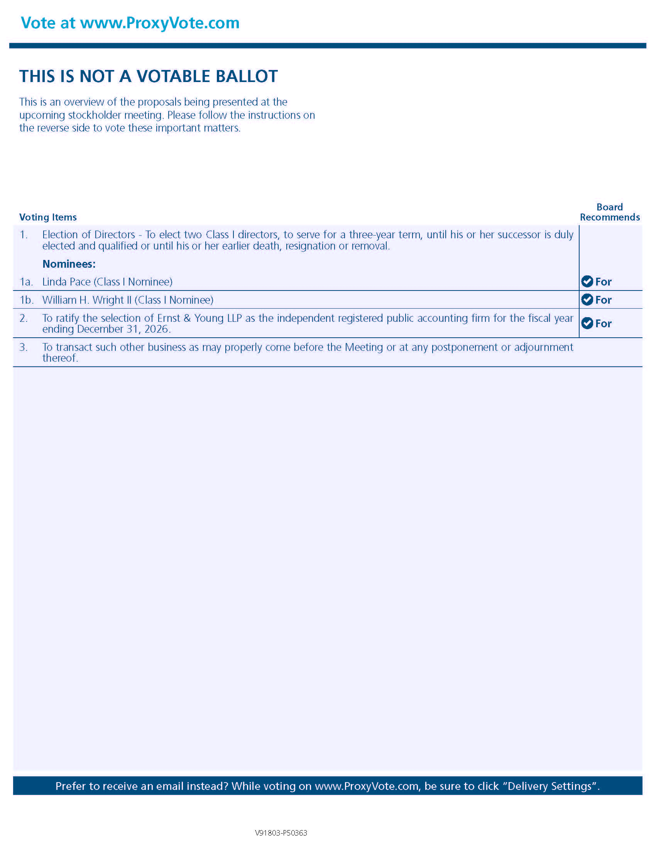
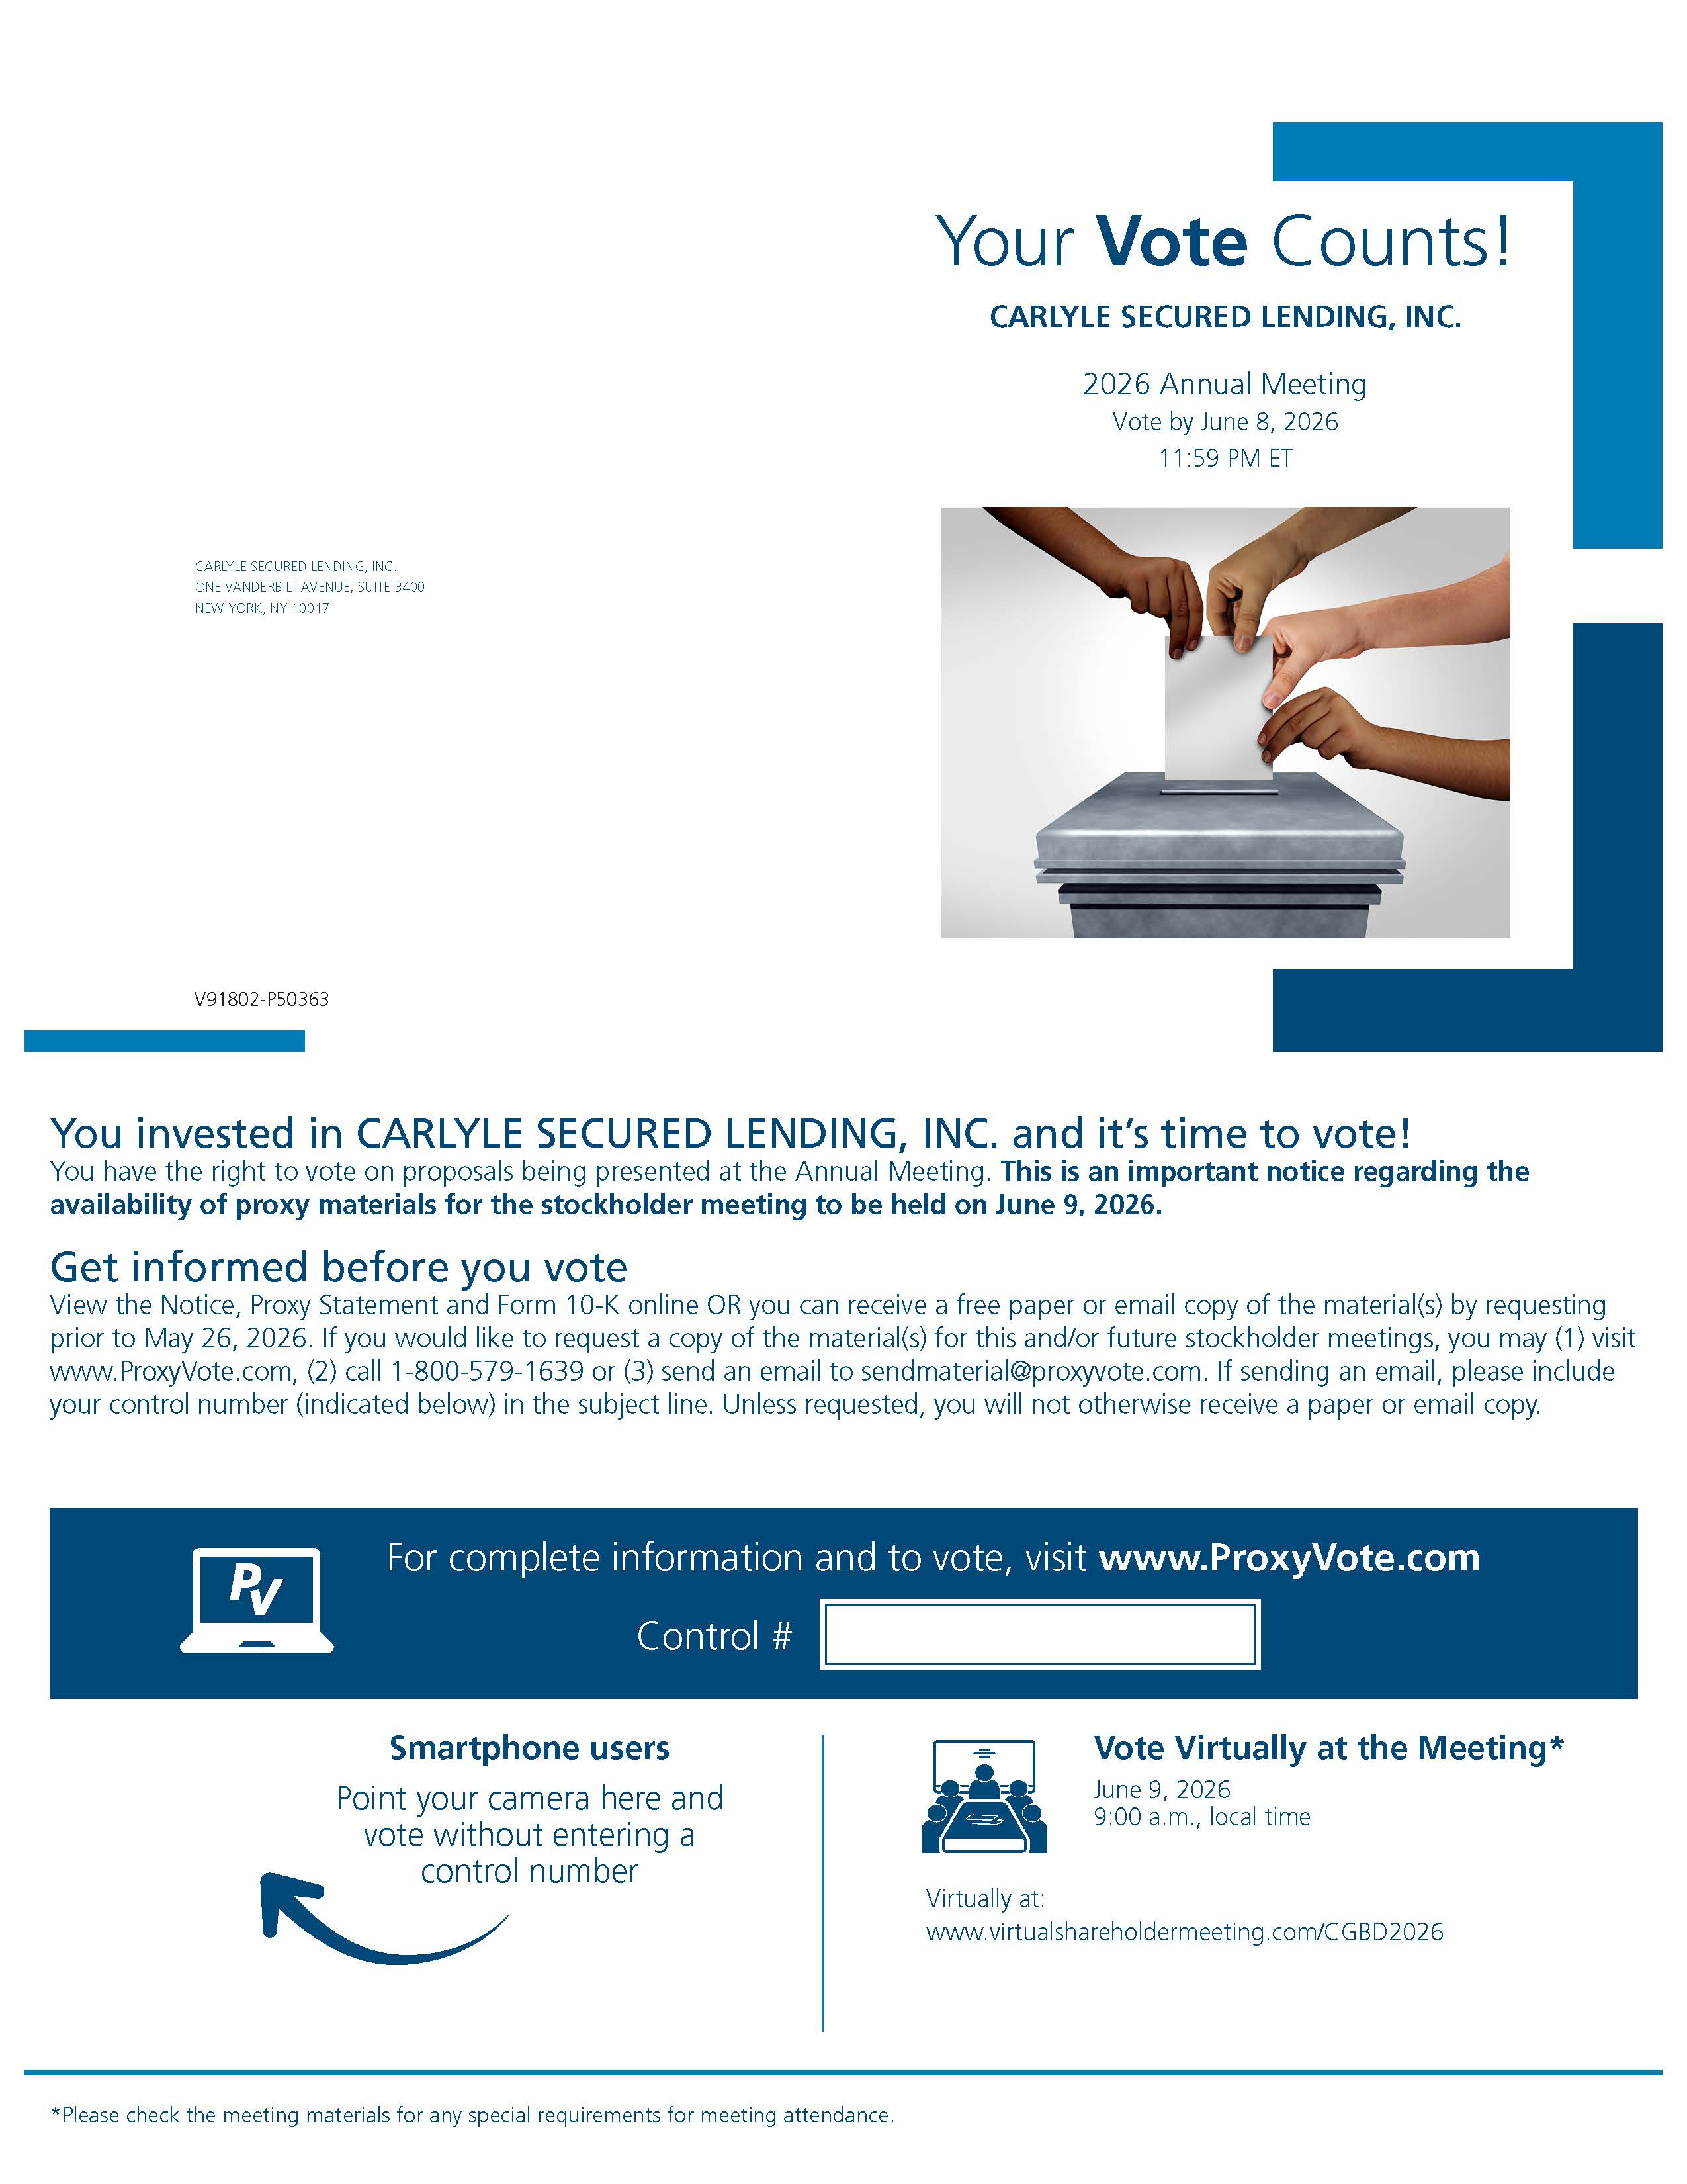
☒
☐
☐

Payment of Filing Fee (Check the appropriate box):

