UNITED STATES
SECURITIES AND EXCHANGE COMMISSION
Washington, DC 20549
FORM 8-K
CURRENT REPORT
Pursuant to Section 13 OR 15(d) of the
Securities Exchange Act of 1934
Date of Report (Date of earliest event reported): August 6, 2026
Carlyle Secured Lending, Inc.
(Exact name of registrant as specified in its charter)
Maryland |  |  |  |  |  | 814-00995 |  |  |  |  |  |  |  |  | 80-0789789
(State or Other Jurisdiction  of Incorporation) |  |  |  |  |  | (Commission  File Number) |  |  |  |  |  |  |  |  | (IRS Employer  Identification No.)
One Vanderbilt Avenue, Suite 3400
New York |  |  |  |  |  | New York |  |  |  |  |  |  |  |  | 10017
(Address of Principal Executive Offices) |  |  |  |  |  |  |  |  |  |  |  |  |  |  | (Zip Code)
(212) 813-4900
(Registrant’s Telephone Number, Including Area Code)
Not Applicable
(Former Name or Former Address, if Changed Since Last Report)
Check the appropriate box below if the Form 8-K filing is intended to simultaneously satisfy the filing obligation of the registrant under any of the following provisions (see General Instruction A.2. below):
☐ |  |  | Written communications pursuant to Rule 425 under the Securities Act (17 CFR 230.425)
☐ |  |  | Soliciting material pursuant to Rule 14a-12 under the Exchange Act (17 CFR 240.14a-12)
☐ |  |  | Pre-commencement communications pursuant to Rule 14d-2(b) under the Exchange Act (17 CFR 240.14d-2(b))
☐ |  |  | Pre-commencement communications pursuant to Rule 13e-4(c) under the Exchange Act (17 CFR 240.13e-4(c))

Securities registered pursuant to Section 12(b) of the Act:
Title of each class |  |  | Trading Symbol(s) |  |  | Name of each exchange on which registered
Common Stock |  |  | CGBD |  |  | The Nasdaq Global Select Market
Indicate by check mark whether the registrant is an emerging growth company as defined in Rule 405 of the Securities Act of 1933 (§230.405 of this chapter) or Rule 12b-2 of the Securities Exchange Act of 1934 (§240.12b-2 of this chapter).
Emerging growth company ☐
If an emerging growth company, indicate by check mark if the registrant has elected not to use the extended transition period for complying with any new or revised financial accounting standards provided pursuant to Section 13(a) of the Exchange Act. ☐

Item 2.02 – Results of Operations and Financial Condition.
On August 6, 2026, Carlyle Secured Lending, Inc. (the “Company”) issued a press release announcing its second quarter ended June 30, 2026 financial results and a detailed earnings presentation. Copies of the press release and the earnings presentation are attached hereto as Exhibit 99.1 and Exhibit 99.2, respectively.
The information disclosed under this Item 2.02, including Exhibits 99.1 and 99.2 hereto, is being furnished and shall not be deemed “filed” for purposes of Section 18 of the Securities Exchange Act of 1934 (the “Exchange Act”), and shall not be deemed incorporated by reference into any filing made under the Securities Act of 1933 (the “Securities Act”) or the Exchange Act, except as expressly set forth by specific reference in such filing.
Item 7.01 – Regulation FD Disclosure.
On August 6, 2026, the Company issued a press release, included herewith as Exhibit 99.1, announcing its second quarter ended 2026 financial results and the declaration of a third quarter 2026 dividend of $0.35 per share payable on October 16, 2026 to stockholders of record as of September 30, 2026.
The information disclosed under this Item 7.01, including Exhibit 99.1 hereto, is being furnished and shall not be deemed “filed” for purposes of Section 18 of the Exchange Act, and shall not be deemed incorporated by reference into any filing made under the Securities Act or the Exchange Act, except as expressly set forth by specific reference in such filing.

Item 9.01 – Financial Statements and Exhibits.
Exhibits 99.1 and 99.2 shall be deemed furnished herewith.

(d)Exhibits:
Exhibit Number |  |  |  |  |  | Description
99.1 |  |  |  |  |  | Earnings press release of Carlyle Secured Lending, Inc., dated August 6, 2026
99.2 |  |  |  |  |  | Earnings presentation of Carlyle Secured Lending, Inc., dated August 6, 2026

SIGNATURES
Pursuant to the requirements of the Securities Exchange Act of 1934, the Registrant has duly caused this report to be signed on its behalf by the undersigned hereunto duly authorized.
 |  |  |  |  |  |  |  |  |  |  |  | CARLYLE SECURED LENDING, INC.
 |  |  |  |  |  |  |  |  |  |  |  | (Registrant)
Dated: August 6, 2026 |  |  |  |  |  | By: |  |  |  |  |  | /s/ Thomas M. Hennigan
 |  |  |  |  |  |  |  |  |  |  |  | Name: Thomas M. Hennigan
Title: Director, President, Chief Financial Officer and Chief Risk Officer
(principal financial officer)

Exhibit 99.1



For Immediate Release
August 6, 2026

Carlyle Secured Lending, Inc. Announces Financial Results For Second Quarter Ended June 30, 2026, Declares Third Quarter 2026 Dividend of $0.35 Per Common Share
New York - Carlyle Secured Lending, Inc. (together with its consolidated subsidiaries, “we,” “us,” “our,” “CGBD” or the “Company”) (NASDAQ: CGBD) today announced its financial results for its second quarter ended June 30, 2026.
Alex Chi, CGBD’s Chief Executive Officer, said, “CGBD had another strong quarter of earnings in the second quarter, with full coverage on the updated quarterly dividend and low non-accruals. We continued to ramp our fee-free joint venture complex, achieving high-teens returns at both investment funds during the second quarter. Looking to the second half of the year, we are focused on continuing to deliver stable income and consistent credit performance, while taking share in the broader direct lending market by leveraging the OneCarlyle platform.”
For the second quarter of 2026, we reported $0.35 per common share of Net Investment Income and Adjusted Net Investment Income, a non-GAAP financial measure described below.
Net asset value per common share decreased by 1.8% for the second quarter to $15.61 from $15.89 as of March 31, 2026. The total fair value of our investments increased to $2.4 billion as of June 30, 2026.
Dividends
On July 29, 2026, the Board of Directors declared a quarterly common dividend of $0.35 per share. The dividend is payable on October 16, 2026 to common stockholders of record on September 30, 2026.
Conference Call
The Company will host a conference call at 11:00 a.m. (Eastern Time) on Friday, August 7, 2026 to discuss these financial results. The conference call will be available via public webcast via a link on our website and will also be available on our website soon after the call’s completion.
Non-GAAP Financial Measures
On a supplemental basis, we are disclosing Adjusted Net Investment Income Per Common Share, which is calculated and presented on a basis other than in accordance with GAAP (“non-GAAP”). We use this non-GAAP financial measure internally to analyze and evaluate financial results and performance, and we believe this non-GAAP financial measure is useful to investors as an additional tool to evaluate our ongoing results and trends and to review our performance without giving effect to (i) the amortization/accretion resulting from the new cost basis of the investments acquired and accounted for under the acquisition method of accounting in accordance with ASC 805 and (ii) the one-time purchase or non-recurring investment income and expense events, including the effects on incentive fees. In addition, the Company’s management uses the non-GAAP financial measure described above internally to analyze and evaluate financial results and performance and to compare the Company’s financial results with those of other business development companies that have not had similar one-time or non-recurring events. The presentation of this non-GAAP measure is not intended to be a substitute for financial results prepared in accordance with GAAP and should not be considered in isolation.
Starting in the first quarter of 2025, the adjustment to net investment income per common share to determine Adjusted Net Investment Income Per Common Share represents the difference between GAAP amortization under the asset acquisition method of accounting in accordance with ASC 805 and management’s non-GAAP measure of amortization related to assets acquired in connection with the CSL III merger on March 27, 2025, and the remaining interest in Middle Market Credit Fund II on

Page | 1
February 11, 2025. This adjustment reflects management’s view of the economic yield on the acquired assets and is consistent with our internal evaluation of performance.
Carlyle Secured Lending, Inc.
CGBD is an externally managed specialty finance company focused on lending to middle-market companies. CGBD is managed by Carlyle Global Credit Investment Management L.L.C., an SEC-registered investment adviser and a wholly owned subsidiary of The Carlyle Group Inc. Since it commenced investment operations in May 2013 through June 30, 2026, CGBD has invested approximately $11.2 billion in aggregate principal amount of debt and equity investments prior to any subsequent exits or repayments. CGBD’s investment objective is to generate current income and capital appreciation primarily through debt investments in U.S. middle market companies. CGBD has elected to be regulated as a business development company under the Investment Company Act of 1940, as amended.
Web: carlylesecuredlending.com
About Carlyle
Carlyle (“Carlyle,” or the “Adviser”) (NASDAQ: CG) is a global investment firm with deep industry expertise that deploys private capital across three business segments: Global Private Equity, Global Credit, and Carlyle AlpInvest. With $485 billion of assets under management as of June 30, 2026, Carlyle’s purpose is to connect people, ideas, and capital to fuel growth for companies and performance for investors. Carlyle employs more than 2,500 people in 28 offices across four continents. Further information is available at www.carlyle.com. Follow Carlyle on X @OneCarlyle and LinkedIn at The Carlyle Group.

Contacts:
Investors: |  |  | Media:
Nishil Mehta |  |  | Brittany Bensaull
+1-212-813-4918 |  |  | +1-212-813-4839
publicinvestor@carlylesecuredlending.com |  |  | brittany.bensaull@carlyle.com
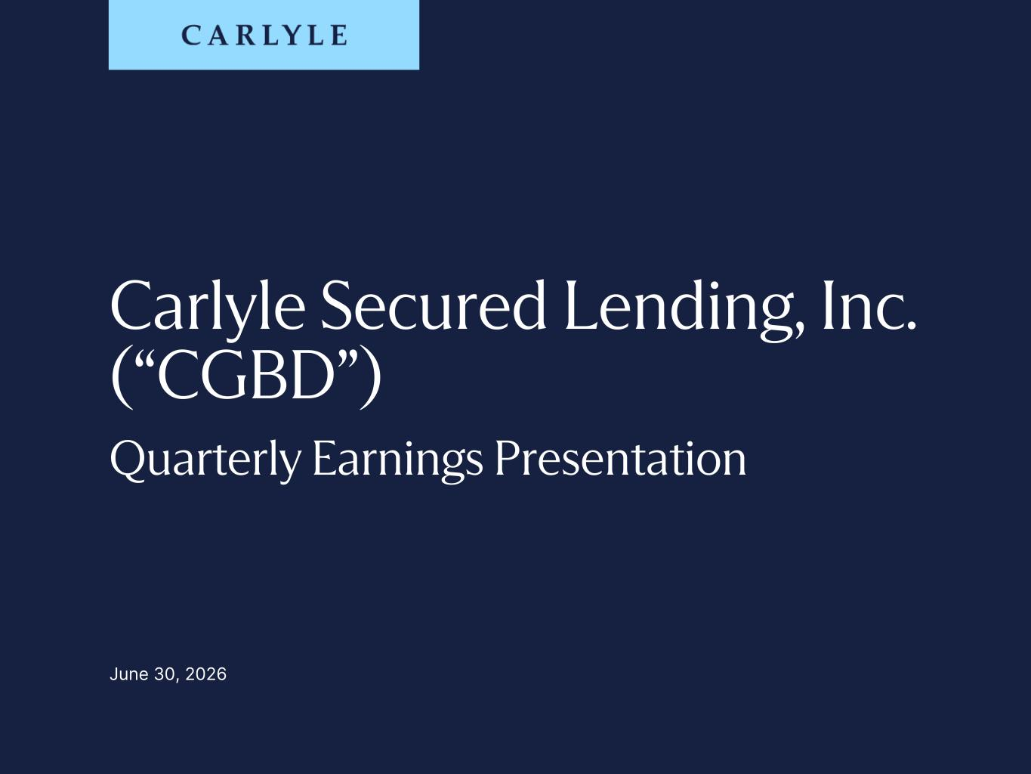
Page | 2
Carlyle Secured Lending, Inc. (“CGBD”) Quarterly Earnings Presentation June 30, 2026

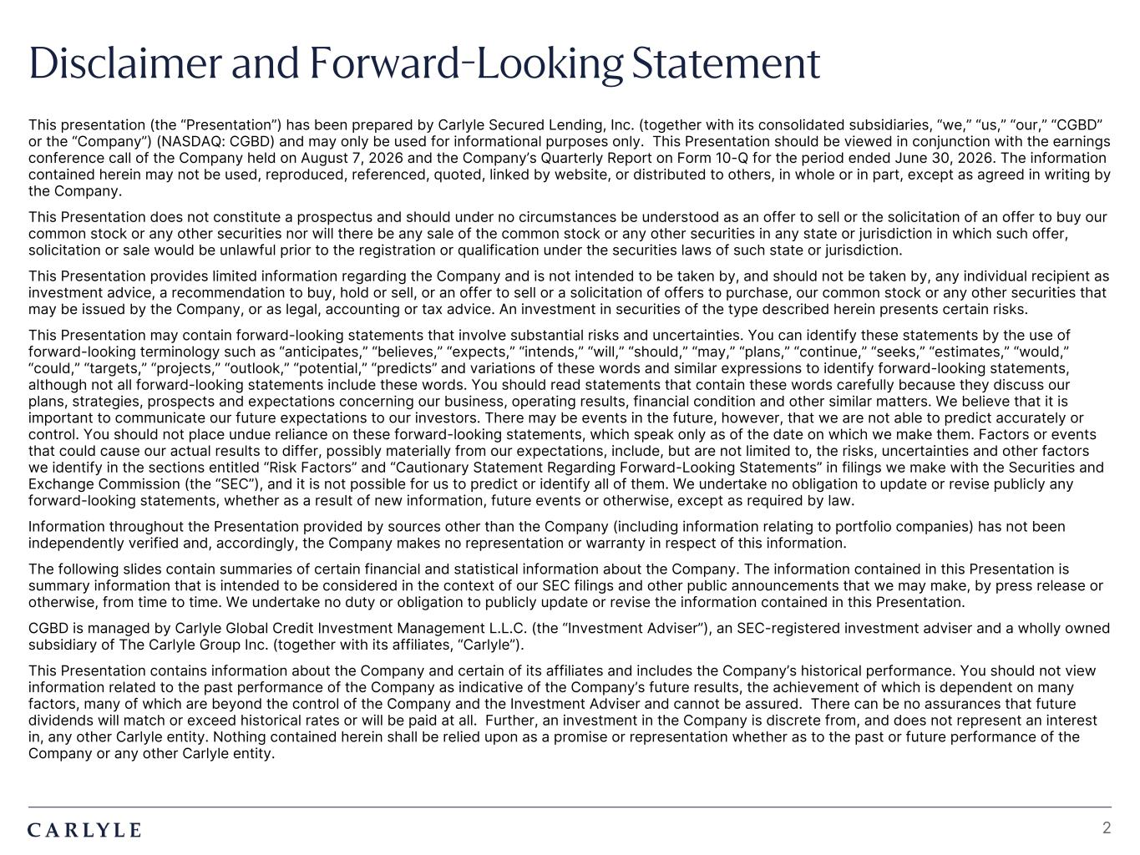
Plum R117 G45 B79 Dark Gray R101 G101 B101 Light Green R216 G240 B221 Pale Blue R221 G244 B255 Light Indigo R176 G188 B228 Indigo R49 G71 B143 Brown R96 G70 B60 Taupe R209 G199 B189 Light Gray R230 G230 B230 Dark Blue R22 G32 B64 Green R57 G108 B101 Champagne R251 G246 B237 Sky Blue R149 G218 B255 Salmon R240 G196 B188 2 Disclaimer and Forward-Looking Statement This presentation (the “Presentation”) has been prepared by Carlyle Secured Lending, Inc. (together with its consolidated subsidiaries, “we,” “us,” “our,” “CGBD” or the “Company”) (NASDAQ: CGBD) and may only be used for informational purposes only. This Presentation should be viewed in conjunction with the earnings conference call of the Company held on August 7, 2026 and the Company’s Quarterly Report on Form 10-Q for the period ended June 30, 2026. The information contained herein may not be used, reproduced, referenced, quoted, linked by website, or distributed to others, in whole or in part, except as agreed in writing by the Company. This Presentation does not constitute a prospectus and should under no circumstances be understood as an offer to sell or the solicitation of an offer to buy our common stock or any other securities nor will there be any sale of the common stock or any other securities in any state or jurisdiction in which such offer, solicitation or sale would be unlawful prior to the registration or qualification under the securities laws of such state or jurisdiction. This Presentation provides limited information regarding the Company and is not intended to be taken by, and should not be taken by, any individual recipient as investment advice, a recommendation to buy, hold or sell, or an offer to sell or a solicitation of offers to purchase, our common stock or any other securities that may be issued by the Company, or as legal, accounting or tax advice. An investment in securities of the type described herein presents certain risks. This Presentation may contain forward-looking statements that involve substantial risks and uncertainties. You can identify these statements by the use of forward-looking terminology such as “anticipates,” “believes,” “expects,” “intends,” “will,” “should,” “may,” “plans,” “continue,” “seeks,” “estimates,” “would,” “could,” “targets,” “projects,” “outlook,” “potential,” “predicts” and variations of these words and similar expressions to identify forward-looking statements, although not all forward-looking statements include these words. You should read statements that contain these words carefully because they discuss our plans, strategies, prospects and expectations concerning our business, operating results, financial condition and other similar matters. We believe that it is important to communicate our future expectations to our investors. There may be events in the future, however, that we are not able to predict accurately or control. You should not place undue reliance on these forward-looking statements, which speak only as of the date on which we make them. Factors or events that could cause our actual results to differ, possibly materially from our expectations, include, but are not limited to, the risks, uncertainties and other factors we identify in the sections entitled “Risk Factors” and “Cautionary Statement Regarding Forward-Looking Statements” in filings we make with the Securities and Exchange Commission (the “SEC”), and it is not possible for us to predict or identify all of them. We undertake no obligation to update or revise publicly any forward-looking statements, whether as a result of new information, future events or otherwise, except as required by law. Information throughout the Presentation provided by sources other than the Company (including information relating to portfolio companies) has not been independently verified and, accordingly, the Company makes no representation or warranty in respect of this information. The following slides contain summaries of certain financial and statistical information about the Company. The information contained in this Presentation is summary information that is intended to be considered in the context of our SEC filings and other public announcements that we may make, by press release or otherwise, from time to time. We undertake no duty or obligation to publicly update or revise the information contained in this Presentation. CGBD is managed by Carlyle Global Credit Investment Management L.L.C. (the “Investment Adviser”), an SEC-registered investment adviser and a wholly owned subsidiary of The Carlyle Group Inc. (together with its affiliates, “Carlyle”). This Presentation contains information about the Company and certain of its affiliates and includes the Company’s historical performance. You should not view information related to the past performance of the Company as indicative of the Company’s future results, the achievement of which is dependent on many factors, many of which are beyond the control of the Company and the Investment Adviser and cannot be assured. There can be no assurances that future dividends will match or exceed historical rates or will be paid at all. Further, an investment in the Company is discrete from, and does not represent an interest in, any other Carlyle entity. Nothing contained herein shall be relied upon as a promise or representation whether as to the past or future performance of the Company or any other Carlyle entity.

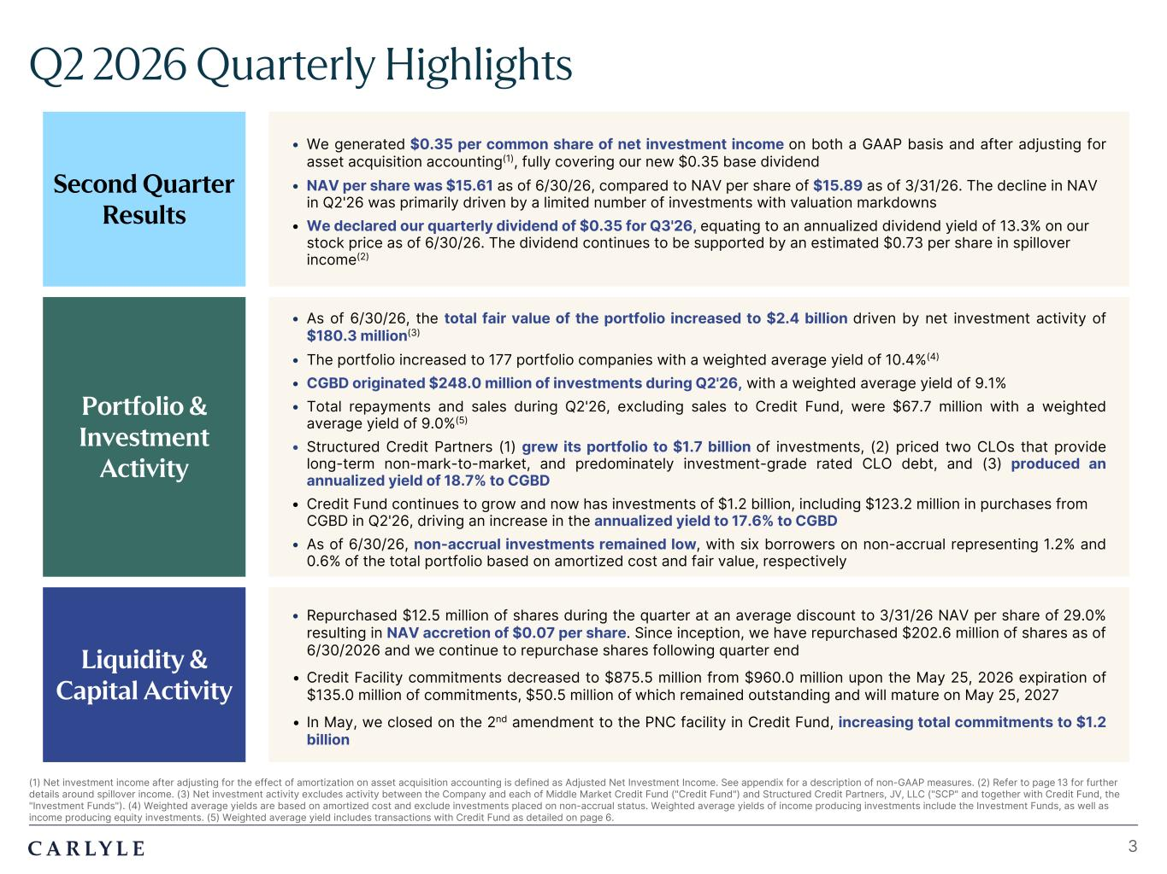
Plum R117 G45 B79 Dark Gray R101 G101 B101 Light Green R216 G240 B221 Pale Blue R221 G244 B255 Light Indigo R176 G188 B228 Indigo R49 G71 B143 Brown R96 G70 B60 Taupe R209 G199 B189 Light Gray R230 G230 B230 Dark Blue R22 G32 B64 Green R57 G108 B101 Champagne R251 G246 B237 Sky Blue R149 G218 B255 Salmon R240 G196 B188 3 (1) Net investment income after adjusting for the effect of amortization on asset acquisition accounting is defined as Adjusted Net Investment Income. See appendix for a description of non-GAAP measures. (2) Refer to page 13 for further details around spillover income. (3) Net investment activity excludes activity between the Company and each of Middle Market Credit Fund ("Credit Fund") and Structured Credit Partners, JV, LLC ("SCP" and together with Credit Fund, the "Investment Funds"). (4) Weighted average yields are based on amortized cost and exclude investments placed on non-accrual status. Weighted average yields of income producing investments include the Investment Funds, as well as income producing equity investments. (5) Weighted average yield includes transactions with Credit Fund as detailed on page 6. Q2 2026 Quarterly Highlights Portfolio & Investment Activity Second Quarter Results • We generated $0.35 per common share of net investment income on both a GAAP basis and after adjusting for asset acquisition accounting(1), fully covering our new $0.35 base dividend • NAV per share was $15.61 as of 6/30/26, compared to NAV per share of $15.89 as of 3/31/26. The decline in NAV in Q2'26 was primarily driven by a limited number of investments with valuation markdowns • We declared our quarterly dividend of $0.35 for Q3'26, equating to an annualized dividend yield of 13.3% on our stock price as of 6/30/26. The dividend continues to be supported by an estimated $0.73 per share in spillover income(2) • As of 6/30/26, the total fair value of the portfolio increased to $2.4 billion driven by net investment activity of $180.3 million(3) • The portfolio increased to 177 portfolio companies with a weighted average yield of 10.4%(4) • CGBD originated $248.0 million of investments during Q2'26, with a weighted average yield of 9.1% • Total repayments and sales during Q2'26, excluding sales to Credit Fund, were $67.7 million with a weighted average yield of 9.0%(5) • Structured Credit Partners (1) grew its portfolio to $1.7 billion of investments, (2) priced two CLOs that provide long-term non-mark-to-market, and predominately investment-grade rated CLO debt, and (3) produced an annualized yield of 18.7% to CGBD • Credit Fund continues to grow and now has investments of $1.2 billion, including $123.2 million in purchases from CGBD in Q2'26, driving an increase in the annualized yield to 17.6% to CGBD • As of 6/30/26, non-accrual investments remained low, with six borrowers on non-accrual representing 1.2% and 0.6% of the total portfolio based on amortized cost and fair value, respectively • Repurchased $12.5 million of shares during the quarter at an average discount to 3/31/26 NAV per share of 29.0% resulting in NAV accretion of $0.07 per share. Since inception, we have repurchased $202.6 million of shares as of 6/30/2026 and we continue to repurchase shares following quarter end • Credit Facility commitments decreased to $875.5 million from $960.0 million upon the May 25, 2026 expiration of $135.0 million of commitments, $50.5 million of which remained outstanding and will mature on May 25, 2027 • In May, we closed on the 2nd amendment to the PNC facility in Credit Fund, increasing total commitments to $1.2 billion Liquidity & Capital Activity

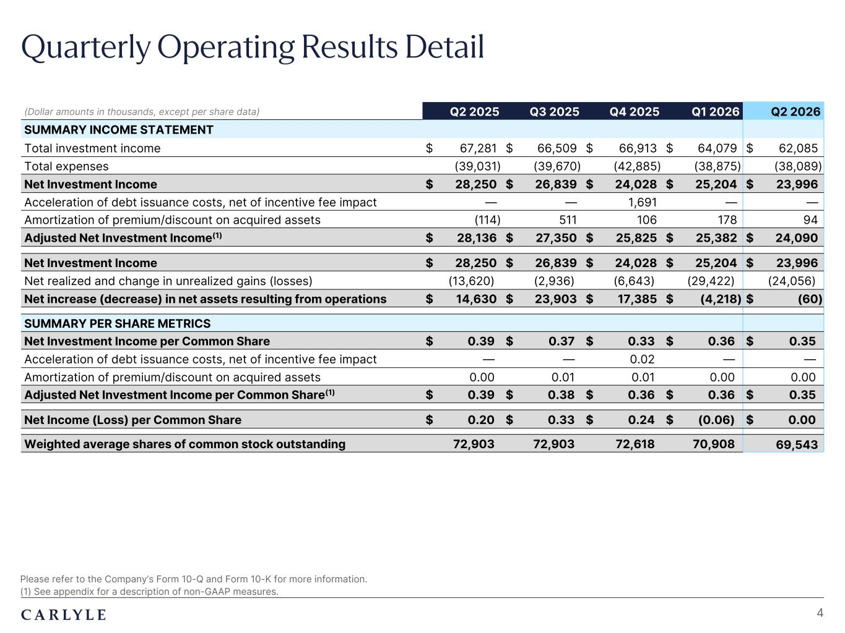
Plum R117 G45 B79 Dark Gray R101 G101 B101 Light Green R216 G240 B221 Pale Blue R221 G244 B255 Light Indigo R176 G188 B228 Indigo R49 G71 B143 Brown R96 G70 B60 Taupe R209 G199 B189 Light Gray R230 G230 B230 Dark Blue R22 G32 B64 Green R57 G108 B101 Champagne R251 G246 B237 Sky Blue R149 G218 B255 Salmon R240 G196 B188 Quarterly Operating Results Detail Please refer to the Company’s Form 10-Q and Form 10-K for more information. (1) See appendix for a description of non-GAAP measures. 4 (Dollar amounts in thousands, except per share data) Q2 2025 Q3 2025 Q4 2025 Q1 2026 Q2 2026 SUMMARY INCOME STATEMENT Total investment income $ 67,281 $ 66,509 $ 66,913 $ 64,079 $ 62,085 Total expenses (39,031) (39,670) (42,885) (38,875) (38,089) Net Investment Income $ 28,250 $ 26,839 $ 24,028 $ 25,204 $ 23,996 Acceleration of debt issuance costs, net of incentive fee impact — — 1,691 — — Amortization of premium/discount on acquired assets (114) 511 106 178 94 Adjusted Net Investment Income(1) $ 28,136 $ 27,350 $ 25,825 $ 25,382 $ 24,090 Net Investment Income $ 28,250 $ 26,839 $ 24,028 $ 25,204 $ 23,996 Net realized and change in unrealized gains (losses) (13,620) (2,936) (6,643) (29,422) (24,056) Net increase (decrease) in net assets resulting from operations $ 14,630 $ 23,903 $ 17,385 $ (4,218) $ (60) SUMMARY PER SHARE METRICS Net Investment Income per Common Share $ 0.39 $ 0.37 $ 0.33 $ 0.36 $ 0.35 Acceleration of debt issuance costs, net of incentive fee impact — — 0.02 — — Amortization of premium/discount on acquired assets 0.00 0.01 0.01 0.00 0.00 Adjusted Net Investment Income per Common Share(1) $ 0.39 $ 0.38 $ 0.36 $ 0.36 $ 0.35 Net Income (Loss) per Common Share $ 0.20 $ 0.33 $ 0.24 $ (0.06) $ 0.00 Weighted average shares of common stock outstanding 72,903 72,903 72,618 70,908 69,543

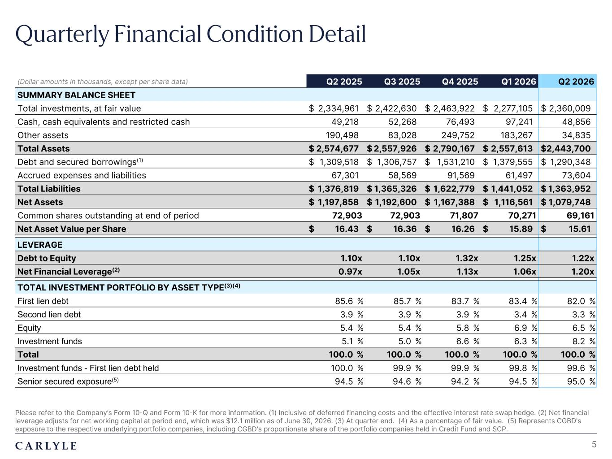
Plum R117 G45 B79 Dark Gray R101 G101 B101 Light Green R216 G240 B221 Pale Blue R221 G244 B255 Light Indigo R176 G188 B228 Indigo R49 G71 B143 Brown R96 G70 B60 Taupe R209 G199 B189 Light Gray R230 G230 B230 Dark Blue R22 G32 B64 Green R57 G108 B101 Champagne R251 G246 B237 Sky Blue R149 G218 B255 Salmon R240 G196 B188 Quarterly Financial Condition Detail 5 (Dollar amounts in thousands, except per share data) Q2 2025 Q3 2025 Q4 2025 Q1 2026 Q2 2026 SUMMARY BALANCE SHEET Total investments, at fair value $ 2,334,961 $ 2,422,630 $ 2,463,922 $ 2,277,105 $ 2,360,009 Cash, cash equivalents and restricted cash 49,218 52,268 76,493 97,241 48,856 Other assets 190,498 83,028 249,752 183,267 34,835 Total Assets $ 2,574,677 $ 2,557,926 $ 2,790,167 $ 2,557,613 $ 2,443,700 Debt and secured borrowings(1) $ 1,309,518 $ 1,306,757 $ 1,531,210 $ 1,379,555 $ 1,290,348 Accrued expenses and liabilities 67,301 58,569 91,569 61,497 73,604 Total Liabilities $ 1,376,819 $ 1,365,326 $ 1,622,779 $ 1,441,052 $ 1,363,952 Net Assets $ 1,197,858 $ 1,192,600 $ 1,167,388 $ 1,116,561 $ 1,079,748 Common shares outstanding at end of period 72,903 72,903 71,807 70,271 69,161 Net Asset Value per Share $ 16.43 $ 16.36 $ 16.26 $ 15.89 $ 15.61 LEVERAGE Debt to Equity 1.10x 1.10x 1.32x 1.25x 1.22x Net Financial Leverage(2) 0.97x 1.05x 1.13x 1.06x 1.20x TOTAL INVESTMENT PORTFOLIO BY ASSET TYPE(3)(4) First lien debt 85.6 % 85.7 % 83.7 % 83.4 % 82.0 % Second lien debt 3.9 % 3.9 % 3.9 % 3.4 % 3.3 % Equity 5.4 % 5.4 % 5.8 % 6.9 % 6.5 % Investment funds 5.1 % 5.0 % 6.6 % 6.3 % 8.2 % Total 100.0 % 100.0 % 100.0 % 100.0 % 100.0 % Investment funds - First lien debt held 100.0 % 99.9 % 99.9 % 99.8 % 99.6 % Senior secured exposure(5) 94.5 % 94.6 % 94.2 % 94.5 % 95.0 % Please refer to the Company’s Form 10-Q and Form 10-K for more information. (1) Inclusive of deferred financing costs and the effective interest rate swap hedge. (2) Net financial leverage adjusts for net working capital at period end, which was $12.1 million as of June 30, 2026. (3) At quarter end. (4) As a percentage of fair value. (5) Represents CGBD's exposure to the respective underlying portfolio companies, including CGBD's proportionate share of the portfolio companies held in Credit Fund and SCP.

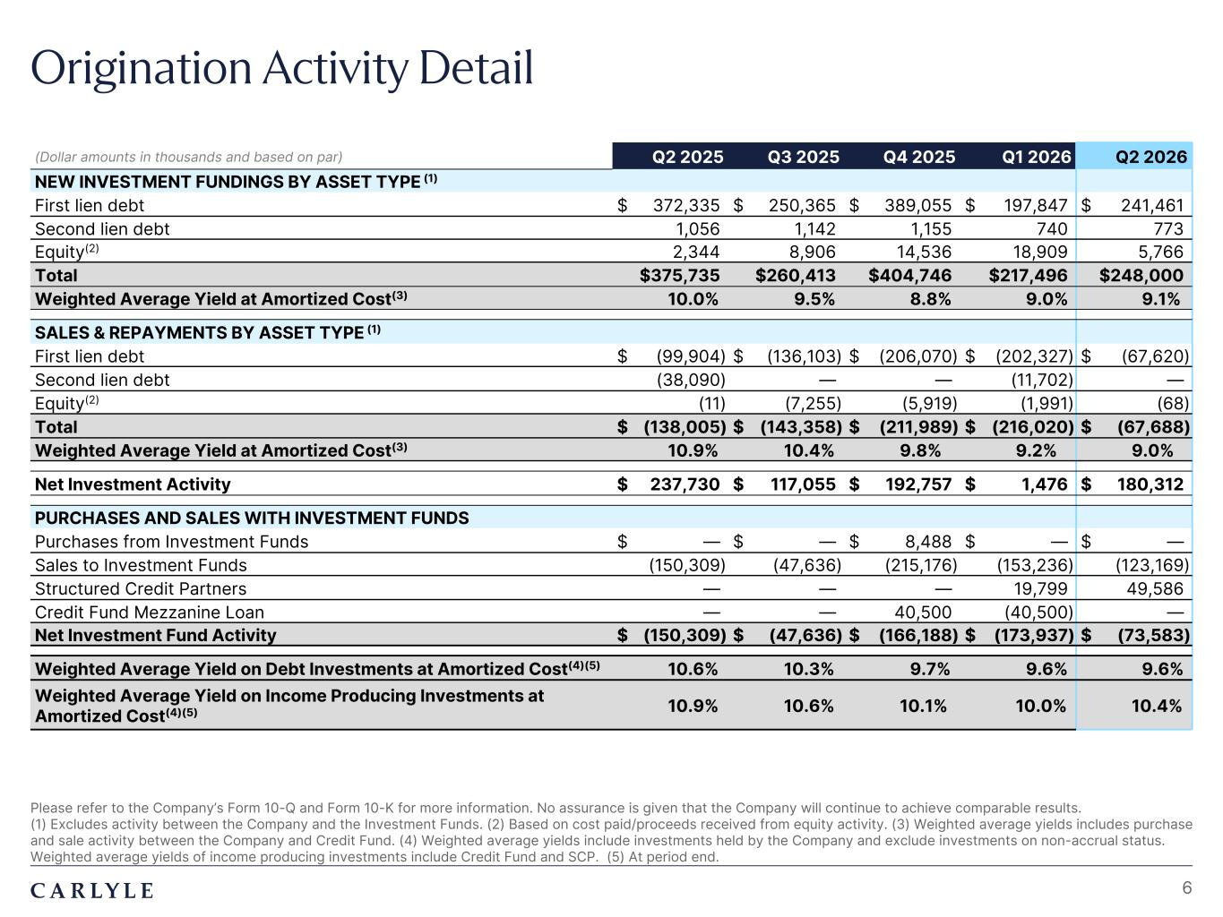
Plum R117 G45 B79 Dark Gray R101 G101 B101 Light Green R216 G240 B221 Pale Blue R221 G244 B255 Light Indigo R176 G188 B228 Indigo R49 G71 B143 Brown R96 G70 B60 Taupe R209 G199 B189 Light Gray R230 G230 B230 Dark Blue R22 G32 B64 Green R57 G108 B101 Champagne R251 G246 B237 Sky Blue R149 G218 B255 Salmon R240 G196 B188 Origination Activity Detail Please refer to the Company’s Form 10-Q and Form 10-K for more information. No assurance is given that the Company will continue to achieve comparable results. (1) Excludes activity between the Company and the Investment Funds. (2) Based on cost paid/proceeds received from equity activity. (3) Weighted average yields includes purchase and sale activity between the Company and Credit Fund. (4) Weighted average yields include investments held by the Company and exclude investments on non-accrual status. Weighted average yields of income producing investments include Credit Fund and SCP. (5) At period end. 6 (Dollar amounts in thousands and based on par) Q2 2025 Q3 2025 Q4 2025 Q1 2026 Q2 2026 NEW INVESTMENT FUNDINGS BY ASSET TYPE (1) First lien debt $ 372,335 $ 250,365 $ 389,055 $ 197,847 $ 241,461 Second lien debt 1,056 1,142 1,155 740 773 Equity(2) 2,344 8,906 14,536 18,909 5,766 Total $375,735 $260,413 $404,746 $217,496 $248,000 Weighted Average Yield at Amortized Cost(3) 10.0% 9.5% 8.8% 9.0% 9.1% SALES & REPAYMENTS BY ASSET TYPE (1) First lien debt $ (99,904) $ (136,103) $ (206,070) $ (202,327) $ (67,620) Second lien debt (38,090) — — (11,702) — Equity(2) (11) (7,255) (5,919) (1,991) (68) Total $ (138,005) $ (143,358) $ (211,989) $ (216,020) $ (67,688) Weighted Average Yield at Amortized Cost(3) 10.9% 10.4% 9.8% 9.2% 9.0% Net Investment Activity $ 237,730 $ 117,055 $ 192,757 $ 1,476 $ 180,312 PURCHASES AND SALES WITH INVESTMENT FUNDS Purchases from Investment Funds $ — $ — $ 8,488 $ — $ — Sales to Investment Funds (150,309) (47,636) (215,176) (153,236) (123,169) Structured Credit Partners — — — 19,799 49,586 Credit Fund Mezzanine Loan — — 40,500 (40,500) — Net Investment Fund Activity $ (150,309) $ (47,636) $ (166,188) $ (173,937) $ (73,583) Weighted Average Yield on Debt Investments at Amortized Cost(4)(5) 10.6% 10.3% 9.7% 9.6% 9.6% Weighted Average Yield on Income Producing Investments at Amortized Cost(4)(5) 10.9% 10.6% 10.1% 10.0% 10.4%

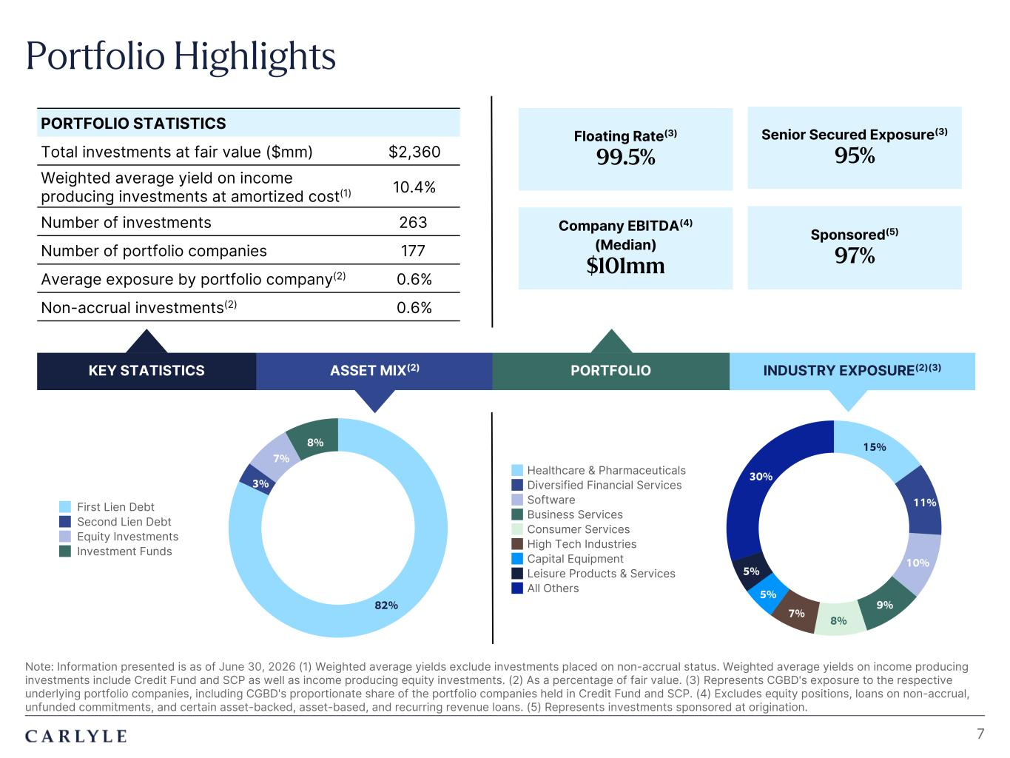
Plum R117 G45 B79 Dark Gray R101 G101 B101 Light Green R216 G240 B221 Pale Blue R221 G244 B255 Light Indigo R176 G188 B228 Indigo R49 G71 B143 Brown R96 G70 B60 Taupe R209 G199 B189 Light Gray R230 G230 B230 Dark Blue R22 G32 B64 Green R57 G108 B101 Champagne R251 G246 B237 Sky Blue R149 G218 B255 Salmon R240 G196 B188 82% 3% 7% 8% First Lien Debt Second Lien Debt Equity Investments Investment Funds 15% 11% 10% 9% 8% 7% 5% 5% 30%Healthcare & Pharmaceuticals Diversified Financial Services Software Business Services Consumer Services High Tech Industries Capital Equipment Leisure Products & Services All Others Portfolio Highlights Note: Information presented is as of June 30, 2026 (1) Weighted average yields exclude investments placed on non-accrual status. Weighted average yields on income producing investments include Credit Fund and SCP as well as income producing equity investments. (2) As a percentage of fair value. (3) Represents CGBD's exposure to the respective underlying portfolio companies, including CGBD's proportionate share of the portfolio companies held in Credit Fund and SCP. (4) Excludes equity positions, loans on non-accrual, unfunded commitments, and certain asset-backed, asset-based, and recurring revenue loans. (5) Represents investments sponsored at origination. 7 KEY STATISTICS ASSET MIX(2) INDUSTRY EXPOSURE(2)(3) PORTFOLIO STATISTICS Total investments at fair value ($mm) $2,360 Weighted average yield on income producing investments at amortized cost(1) 10.4% Number of investments 263 Number of portfolio companies 177 Average exposure by portfolio company(2) 0.6% Non-accrual investments(2) 0.6% Senior Secured Exposure(3) 95% Floating Rate(3) 99.5% Company EBITDA(4) (Median) $101mm Sponsored(5) 97% PORTFOLIO

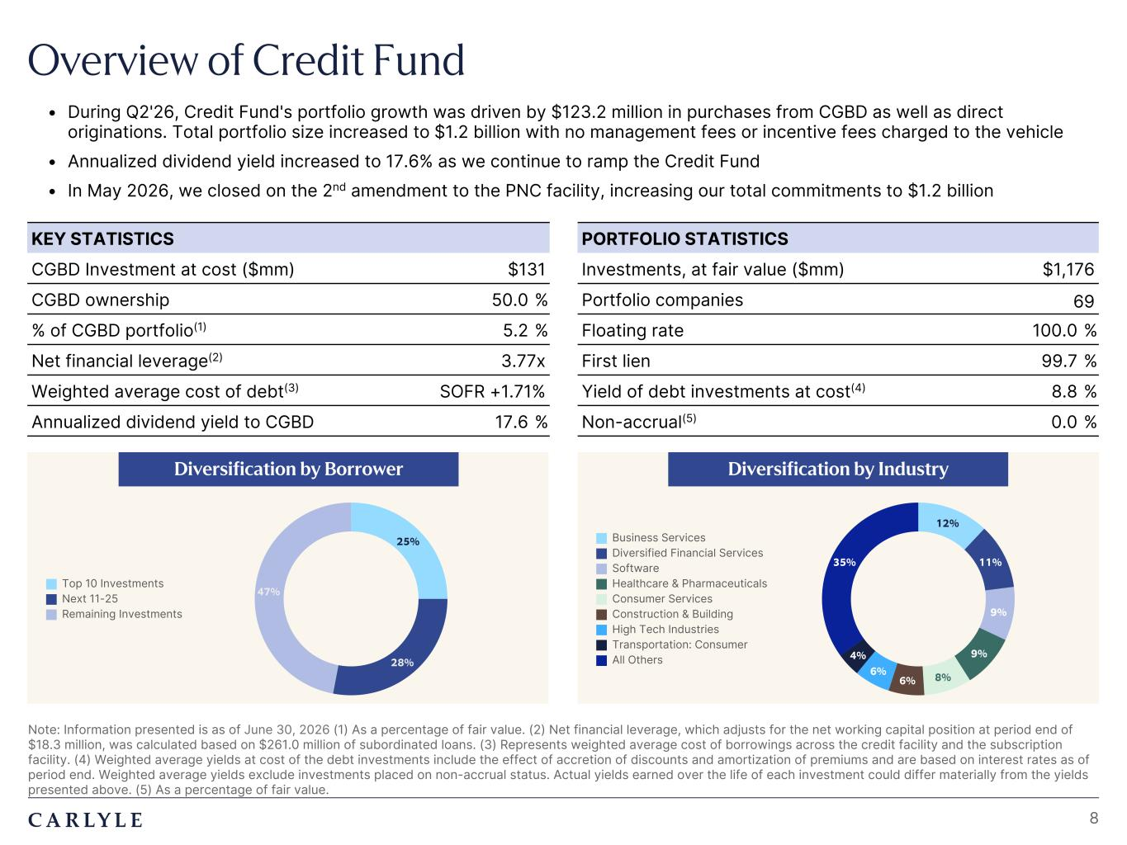
Plum R117 G45 B79 Dark Gray R101 G101 B101 Light Green R216 G240 B221 Pale Blue R221 G244 B255 Light Indigo R176 G188 B228 Indigo R49 G71 B143 Brown R96 G70 B60 Taupe R209 G199 B189 Light Gray R230 G230 B230 Dark Blue R22 G32 B64 Green R57 G108 B101 Champagne R251 G246 B237 Sky Blue R149 G218 B255 Salmon R240 G196 B188 • During Q2'26, Credit Fund's portfolio growth was driven by $123.2 million in purchases from CGBD as well as direct originations. Total portfolio size increased to $1.2 billion with no management fees or incentive fees charged to the vehicle • Annualized dividend yield increased to 17.6% as we continue to ramp the Credit Fund • In May 2026, we closed on the 2nd amendment to the PNC facility, increasing our total commitments to $1.2 billion Overview of Credit Fund Note: Information presented is as of June 30, 2026 (1) As a percentage of fair value. (2) Net financial leverage, which adjusts for the net working capital position at period end of $18.3 million, was calculated based on $261.0 million of subordinated loans. (3) Represents weighted average cost of borrowings across the credit facility and the subscription facility. (4) Weighted average yields at cost of the debt investments include the effect of accretion of discounts and amortization of premiums and are based on interest rates as of period end. Weighted average yields exclude investments placed on non-accrual status. Actual yields earned over the life of each investment could differ materially from the yields presented above. (5) As a percentage of fair value. KEY STATISTICS CGBD Investment at cost ($mm) $131 CGBD ownership 50.0 % % of CGBD portfolio(1) 5.2 % Net financial leverage(2) 3.77x Weighted average cost of debt(3) SOFR +1.71% Annualized dividend yield to CGBD 17.6 % PORTFOLIO STATISTICS Investments, at fair value ($mm) $1,176 Portfolio companies 69 Floating rate 100.0 % First lien 99.7 % Yield of debt investments at cost(4) 8.8 % Non-accrual(5) 0.0 % Diversification by Borrower Diversification by Industry 8 25% 28% 47% Top 10 Investments Next 11-25 Remaining Investments 12% 11% 9% 9% 8%6% 6% 4% 35% Business Services Diversified Financial Services Software Healthcare & Pharmaceuticals Consumer Services Construction & Building High Tech Industries Transportation: Consumer All Others

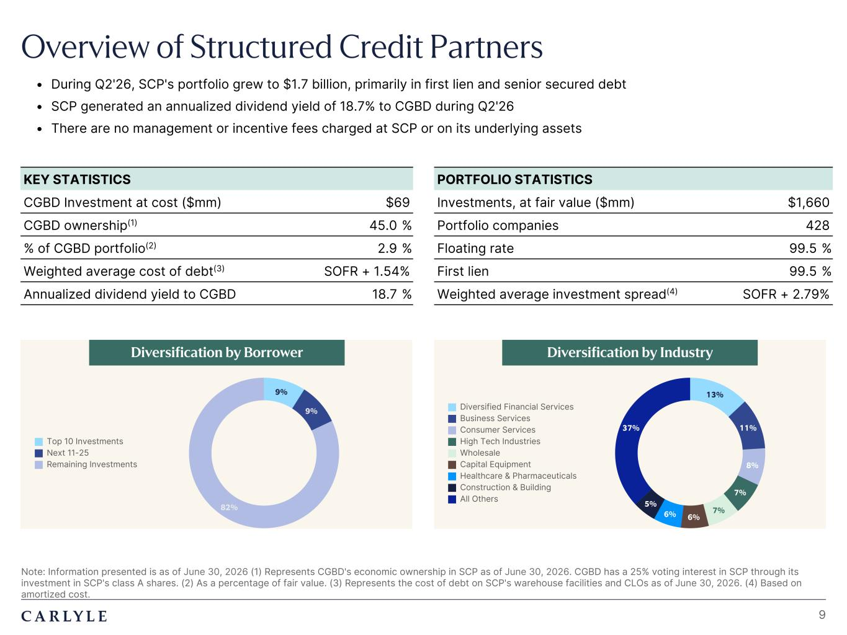
Plum R117 G45 B79 Dark Gray R101 G101 B101 Light Green R216 G240 B221 Pale Blue R221 G244 B255 Light Indigo R176 G188 B228 Indigo R49 G71 B143 Brown R96 G70 B60 Taupe R209 G199 B189 Light Gray R230 G230 B230 Dark Blue R22 G32 B64 Green R57 G108 B101 Champagne R251 G246 B237 Sky Blue R149 G218 B255 Salmon R240 G196 B188 Overview of Structured Credit Partners Note: Information presented is as of June 30, 2026 (1) Represents CGBD's economic ownership in SCP as of June 30, 2026. CGBD has a 25% voting interest in SCP through its investment in SCP's class A shares. (2) As a percentage of fair value. (3) Represents the cost of debt on SCP's warehouse facilities and CLOs as of June 30, 2026. (4) Based on amortized cost. • During Q2'26, SCP's portfolio grew to $1.7 billion, primarily in first lien and senior secured debt • SCP generated an annualized dividend yield of 18.7% to CGBD during Q2'26 • There are no management or incentive fees charged at SCP or on its underlying assets KEY STATISTICS CGBD Investment at cost ($mm) $69 CGBD ownership(1) 45.0 % % of CGBD portfolio(2) 2.9 % Weighted average cost of debt(3) SOFR + 1.54% Annualized dividend yield to CGBD 18.7 % PORTFOLIO STATISTICS Investments, at fair value ($mm) $1,660 Portfolio companies 428 Floating rate 99.5 % First lien 99.5 % Weighted average investment spread(4) SOFR + 2.79% Diversification by Borrower Diversification by Industry 9 9% 9% 82% Top 10 Investments Next 11-25 Remaining Investments 13% 11% 8% 7% 7% 6%6% 5% 37% Diversified Financial Services Business Services Consumer Services High Tech Industries Wholesale Capital Equipment Healthcare & Pharmaceuticals Construction & Building All Others

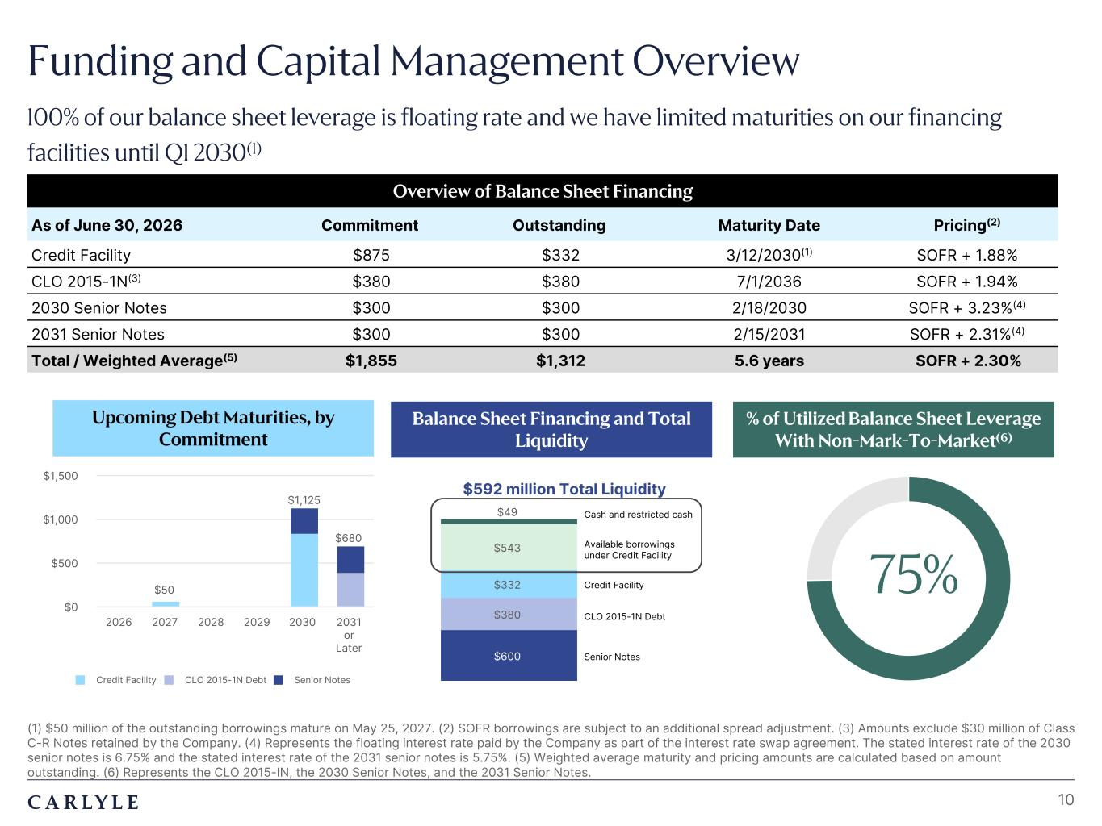
Plum R117 G45 B79 Dark Gray R101 G101 B101 Light Green R216 G240 B221 Pale Blue R221 G244 B255 Light Indigo R176 G188 B228 Indigo R49 G71 B143 Brown R96 G70 B60 Taupe R209 G199 B189 Light Gray R230 G230 B230 Dark Blue R22 G32 B64 Green R57 G108 B101 Champagne R251 G246 B237 Sky Blue R149 G218 B255 Salmon R240 G196 B188 Cash and restricted cash $600 $380 $332 $543 $49 Available borrowings under Credit Facility Funding and Capital Management Overview 100% of our balance sheet leverage is floating rate and we have limited maturities on our financing facilities until Q1 2030(1) 10 (1) $50 million of the outstanding borrowings mature on May 25, 2027. (2) SOFR borrowings are subject to an additional spread adjustment. (3) Amounts exclude $30 million of Class C-R Notes retained by the Company. (4) Represents the floating interest rate paid by the Company as part of the interest rate swap agreement. The stated interest rate of the 2030 senior notes is 6.75% and the stated interest rate of the 2031 senior notes is 5.75%. (5) Weighted average maturity and pricing amounts are calculated based on amount outstanding. (6) Represents the CLO 2015-IN, the 2030 Senior Notes, and the 2031 Senior Notes. Balance Sheet Financing and Total Liquidity % of Utilized Balance Sheet Leverage With Non-Mark-To-Market(6) Upcoming Debt Maturities, by Commitment Overview of Balance Sheet Financing As of June 30, 2026 Commitment Outstanding Maturity Date Pricing(2) Credit Facility $875 $332 3/12/2030(1) SOFR + 1.88% CLO 2015-1N(3) $380 $380 7/1/2036 SOFR + 1.94% 2030 Senior Notes $300 $300 2/18/2030 SOFR + 3.23%(4) 2031 Senior Notes $300 $300 2/15/2031 SOFR + 2.31%(4) Total / Weighted Average(5) $1,855 $1,312 5.6 years SOFR + 2.30% $50 $1,125 $680 Credit Facility CLO 2015-1N Debt Senior Notes 2026 2027 2028 2029 2030 2031 or Later $0 $500 $1,000 $1,500 75% Senior Notes CLO 2015-1N Debt Credit Facility $592 million Total Liquidity

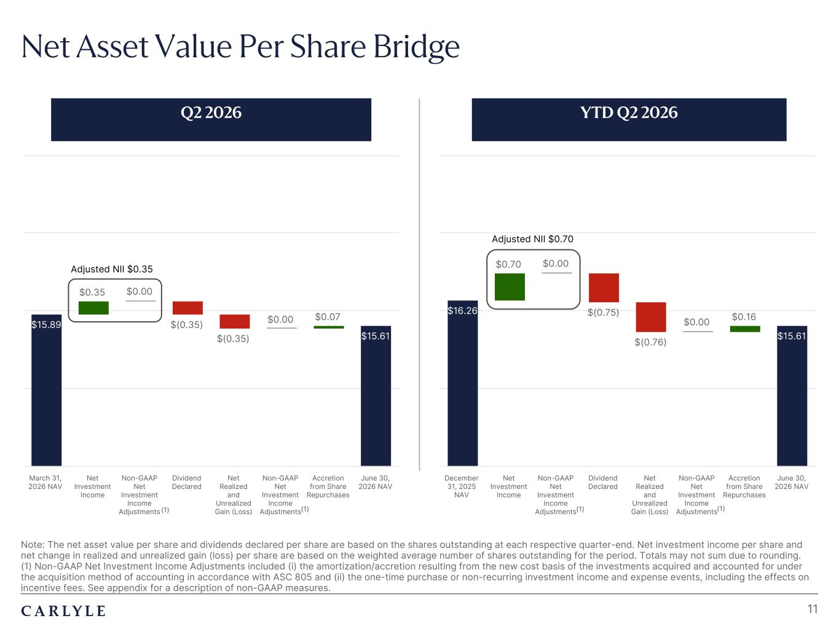
Plum R117 G45 B79 Dark Gray R101 G101 B101 Light Green R216 G240 B221 Pale Blue R221 G244 B255 Light Indigo R176 G188 B228 Indigo R49 G71 B143 Brown R96 G70 B60 Taupe R209 G199 B189 Light Gray R230 G230 B230 Dark Blue R22 G32 B64 Green R57 G108 B101 Champagne R251 G246 B237 Sky Blue R149 G218 B255 Salmon R240 G196 B188 $15.89 $0.35 $0.00 $(0.35) $(0.35) $0.00 $0.07 $15.61 March 31, 2026 NAV Net Investment Income Non-GAAP Net Investment Income Adjustments Dividend Declared Net Realized and Unrealized Gain (Loss) Non-GAAP Net Investment Income Adjustments Accretion from Share Repurchases June 30, 2026 NAV $16.26 $0.70 $0.00 $(0.75) $(0.76) $0.00 $0.16 $15.61 December 31, 2025 NAV Net Investment Income Non-GAAP Net Investment Income Adjustments Dividend Declared Net Realized and Unrealized Gain (Loss) Non-GAAP Net Investment Income Adjustments Accretion from Share Repurchases June 30, 2026 NAV Note: The net asset value per share and dividends declared per share are based on the shares outstanding at each respective quarter-end. Net investment income per share and net change in realized and unrealized gain (loss) per share are based on the weighted average number of shares outstanding for the period. Totals may not sum due to rounding. (1) Non-GAAP Net Investment Income Adjustments included (i) the amortization/accretion resulting from the new cost basis of the investments acquired and accounted for under the acquisition method of accounting in accordance with ASC 805 and (ii) the one-time purchase or non-recurring investment income and expense events, including the effects on incentive fees. See appendix for a description of non-GAAP measures. Net Asset Value Per Share Bridge 11 Q2 2026 YTD Q2 2026 Adjusted NII $0.35 Adjusted NII $0.70 (1) (1) (1) (1)

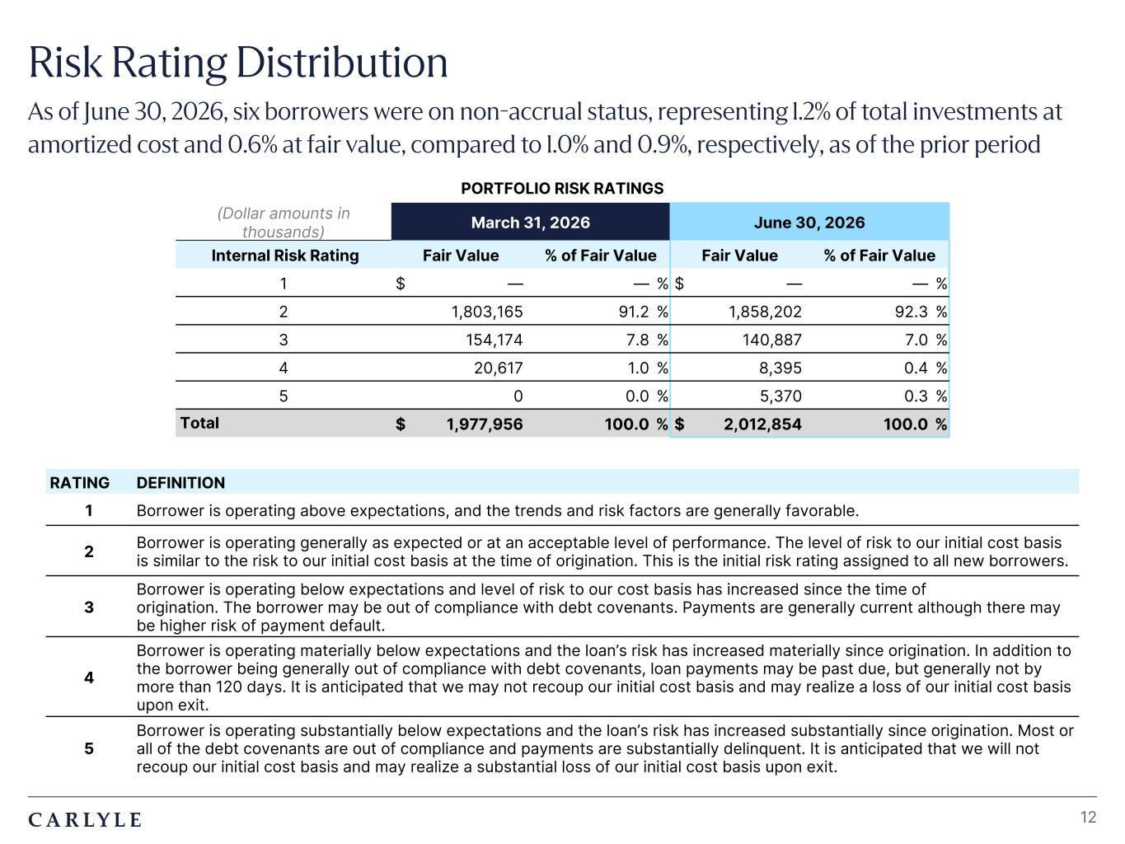
Plum R117 G45 B79 Dark Gray R101 G101 B101 Light Green R216 G240 B221 Pale Blue R221 G244 B255 Light Indigo R176 G188 B228 Indigo R49 G71 B143 Brown R96 G70 B60 Taupe R209 G199 B189 Light Gray R230 G230 B230 Dark Blue R22 G32 B64 Green R57 G108 B101 Champagne R251 G246 B237 Sky Blue R149 G218 B255 Salmon R240 G196 B188 Risk Rating Distribution As of June 30, 2026, six borrowers were on non-accrual status, representing 1.2% of total investments at amortized cost and 0.6% at fair value, compared to 1.0% and 0.9%, respectively, as of the prior period 12 RATING DEFINITION 1 Borrower is operating above expectations, and the trends and risk factors are generally favorable. 2 Borrower is operating generally as expected or at an acceptable level of performance. The level of risk to our initial cost basis is similar to the risk to our initial cost basis at the time of origination. This is the initial risk rating assigned to all new borrowers. 3 Borrower is operating below expectations and level of risk to our cost basis has increased since the time of origination. The borrower may be out of compliance with debt covenants. Payments are generally current although there may be higher risk of payment default. 4 Borrower is operating materially below expectations and the loan’s risk has increased materially since origination. In addition to the borrower being generally out of compliance with debt covenants, loan payments may be past due, but generally not by more than 120 days. It is anticipated that we may not recoup our initial cost basis and may realize a loss of our initial cost basis upon exit. 5 Borrower is operating substantially below expectations and the loan’s risk has increased substantially since origination. Most or all of the debt covenants are out of compliance and payments are substantially delinquent. It is anticipated that we will not recoup our initial cost basis and may realize a substantial loss of our initial cost basis upon exit. PORTFOLIO RISK RATINGS (Dollar amounts in thousands) March 31, 2026 June 30, 2026 Internal Risk Rating Fair Value % of Fair Value Fair Value % of Fair Value 1 $ — — % $ — — % 2 1,803,165 91.2 % 1,858,202 92.3 % 3 154,174 7.8 % 140,887 7.0 % 4 20,617 1.0 % 8,395 0.4 % 5 0 0.0 % 5,370 0.3 % Total $ 1,977,956 100.0 % $ 2,012,854 100.0 %

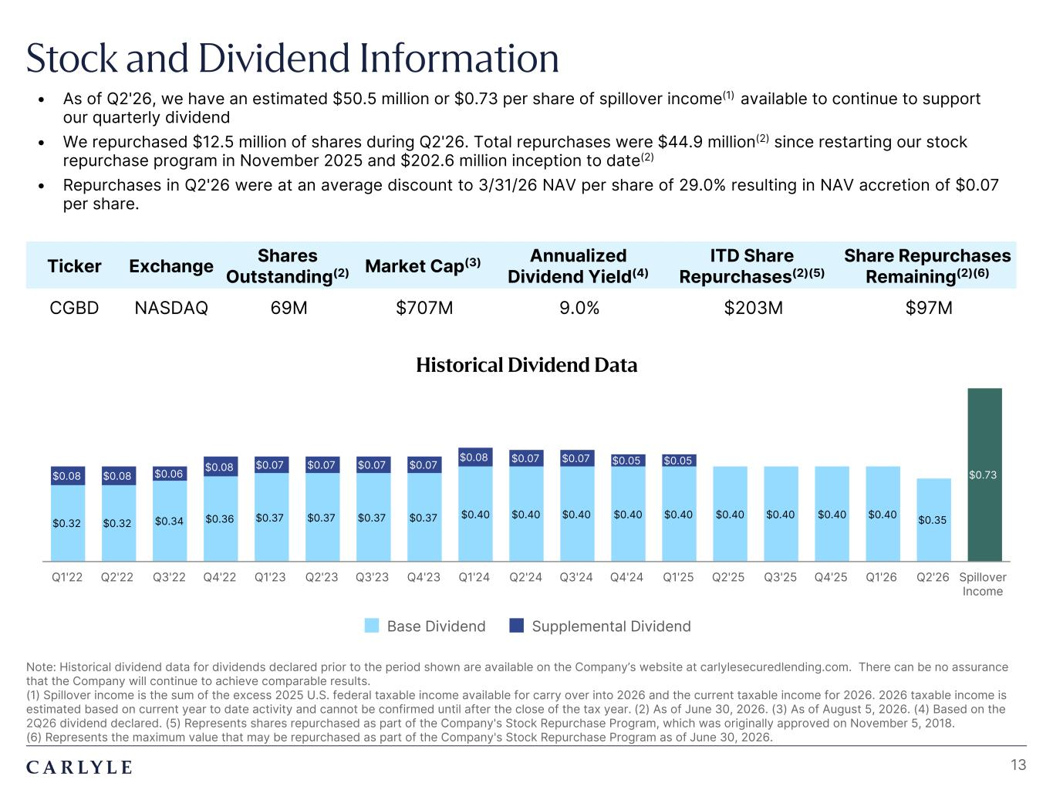
Plum R117 G45 B79 Dark Gray R101 G101 B101 Light Green R216 G240 B221 Pale Blue R221 G244 B255 Light Indigo R176 G188 B228 Indigo R49 G71 B143 Brown R96 G70 B60 Taupe R209 G199 B189 Light Gray R230 G230 B230 Dark Blue R22 G32 B64 Green R57 G108 B101 Champagne R251 G246 B237 Sky Blue R149 G218 B255 Salmon R240 G196 B188 Stock and Dividend Information Note: Historical dividend data for dividends declared prior to the period shown are available on the Company’s website at carlylesecuredlending.com. There can be no assurance that the Company will continue to achieve comparable results. (1) Spillover income is the sum of the excess 2025 U.S. federal taxable income available for carry over into 2026 and the current taxable income for 2026. 2026 taxable income is estimated based on current year to date activity and cannot be confirmed until after the close of the tax year. (2) As of June 30, 2026. (3) As of August 5, 2026. (4) Based on the 2Q26 dividend declared. (5) Represents shares repurchased as part of the Company's Stock Repurchase Program, which was originally approved on November 5, 2018. (6) Represents the maximum value that may be repurchased as part of the Company's Stock Repurchase Program as of June 30, 2026. 13 • As of Q2'26, we have an estimated $50.5 million or $0.73 per share of spillover income(1) available to continue to support our quarterly dividend • We repurchased $12.5 million of shares during Q2'26. Total repurchases were $44.9 million(2) since restarting our stock repurchase program in November 2025 and $202.6 million inception to date(2) • Repurchases in Q2'26 were at an average discount to 3/31/26 NAV per share of 29.0% resulting in NAV accretion of $0.07 per share. Ticker Exchange Shares Outstanding(2) Market Cap(3) Annualized Dividend Yield(4) ITD Share Repurchases(2)(5) Share Repurchases Remaining(2)(6) CGBD NASDAQ 69M $707M 9.0% $203M $97M Historical Dividend Data $0.32 $0.32 $0.34 $0.36 $0.37 $0.37 $0.37 $0.37 $0.40 $0.40 $0.40 $0.40 $0.40 $0.40 $0.40 $0.40 $0.40 $0.35 $0.73$0.08 $0.08 $0.06 $0.08 $0.07 $0.07 $0.07 $0.07 $0.08 $0.07 $0.07 $0.05 $0.05 Base Dividend Supplemental Dividend Q1'22 Q2'22 Q3'22 Q4'22 Q1'23 Q2'23 Q3'23 Q4'23 Q1'24 Q2'24 Q3'24 Q4'24 Q1'25 Q2'25 Q3'25 Q4'25 Q1'26 Q2'26 Spillover Income

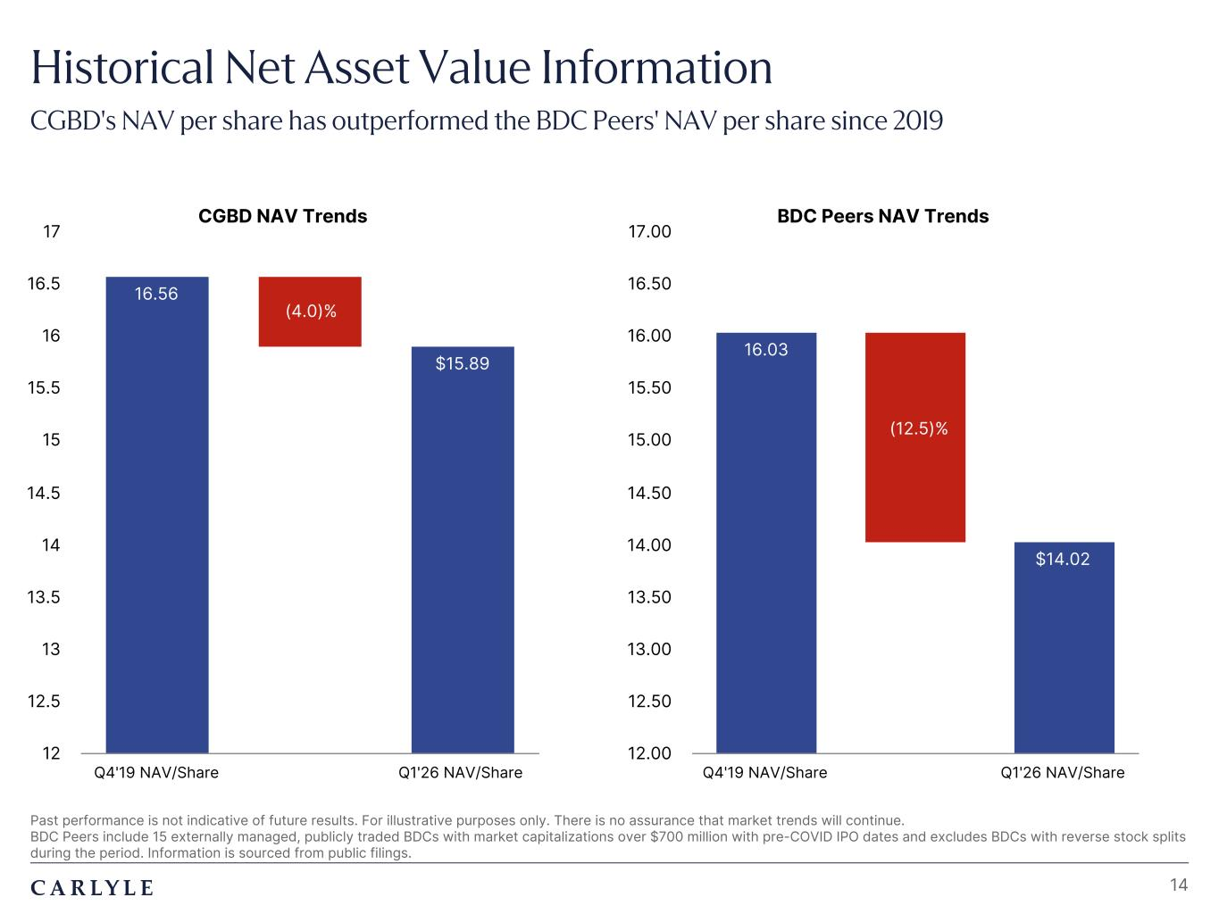
Plum R117 G45 B79 Dark Gray R101 G101 B101 Light Green R216 G240 B221 Pale Blue R221 G244 B255 Light Indigo R176 G188 B228 Indigo R49 G71 B143 Brown R96 G70 B60 Taupe R209 G199 B189 Light Gray R230 G230 B230 Dark Blue R22 G32 B64 Green R57 G108 B101 Champagne R251 G246 B237 Sky Blue R149 G218 B255 Salmon R240 G196 B188 Historical Net Asset Value Information CGBD's NAV per share has outperformed the BDC Peers' NAV per share since 2019 14 Past performance is not indicative of future results. For illustrative purposes only. There is no assurance that market trends will continue. BDC Peers include 15 externally managed, publicly traded BDCs with market capitalizations over $700 million with pre-COVID IPO dates and excludes BDCs with reverse stock splits during the period. Information is sourced from public filings. (4%) (13%) CGBD NAV Trends 16.56 $15.89 Q4'19 NAV/Share Q1'26 NAV/Share 12 12.5 13 13.5 14 14.5 15 15.5 16 16.5 17 (4.0)% BDC Peers NAV Trends 16.03 $14.02 Q4'19 NAV/Share Q1'26 NAV/Share 12.00 12.50 13.00 13.50 14.00 14.50 15.00 15.50 16.00 16.50 17.00 (12.5)%

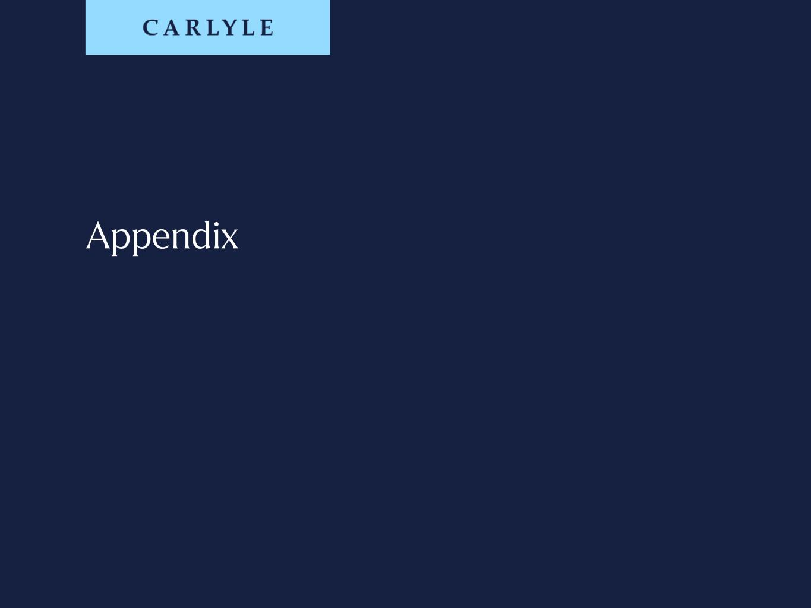
Appendix

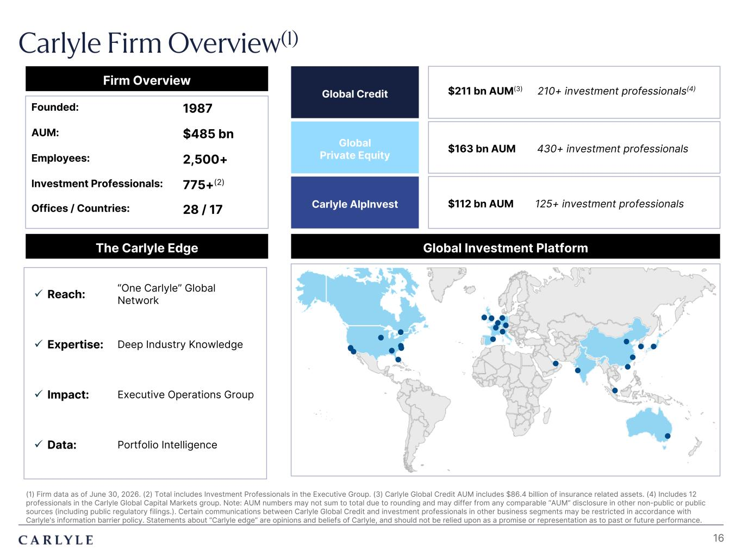
Plum R117 G45 B79 Dark Gray R101 G101 B101 Light Green R216 G240 B221 Pale Blue R221 G244 B255 Light Indigo R176 G188 B228 Indigo R49 G71 B143 Brown R96 G70 B60 Taupe R209 G199 B189 Light Gray R230 G230 B230 Dark Blue R22 G32 B64 Green R57 G108 B101 Champagne R251 G246 B237 Sky Blue R149 G218 B255 Salmon R240 G196 B188 (1) Firm data as of June 30, 2026. (2) Total includes Investment Professionals in the Executive Group. (3) Carlyle Global Credit AUM includes $86.4 billion of insurance related assets. (4) Includes 12 professionals in the Carlyle Global Capital Markets group. Note: AUM numbers may not sum to total due to rounding and may differ from any comparable “AUM” disclosure in other non-public or public sources (including public regulatory filings.). Certain communications between Carlyle Global Credit and investment professionals in other business segments may be restricted in accordance with Carlyle's information barrier policy. Statements about “Carlyle edge” are opinions and beliefs of Carlyle, and should not be relied upon as a promise or representation as to past or future performance. Firm Overview The Carlyle Edge ü Reach: “One Carlyle” Global Network ü Expertise: Deep Industry Knowledge ü Impact: Executive Operations Group ü Data: Portfolio Intelligence Global Private Equity Global Credit Carlyle AlpInvest Global Investment Platform Founded: 1987 AUM: $485 bn Employees: 2,500+ Investment Professionals: 775+(2) Offices / Countries: 28 / 17 $163 bn AUM 430+ investment professionals $211 bn AUM(3) 210+ investment professionals(4) $112 bn AUM 125+ investment professionals Carlyle Firm Overview(1) 16

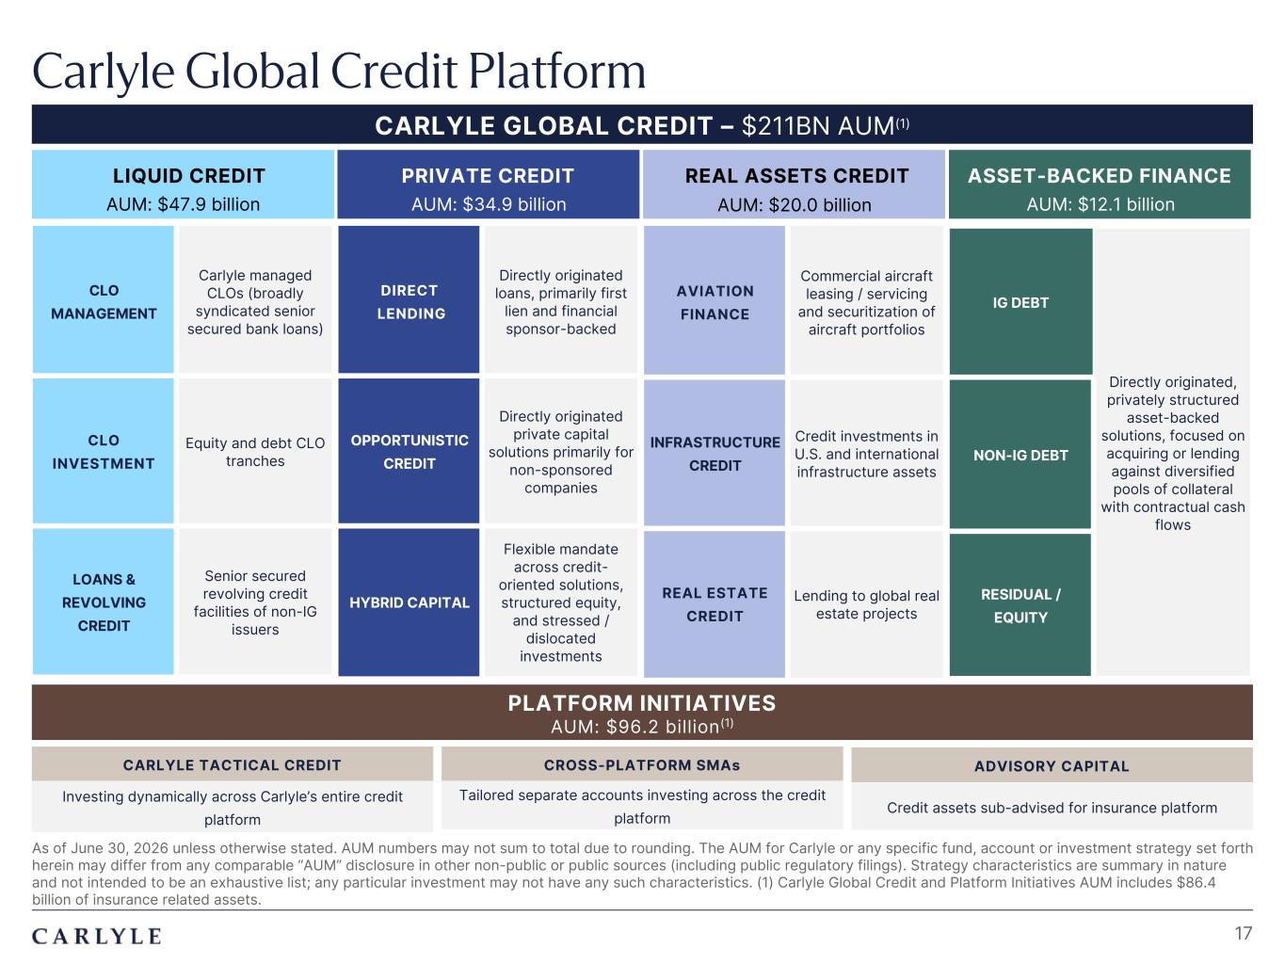
Plum R117 G45 B79 Dark Gray R101 G101 B101 Light Green R216 G240 B221 Pale Blue R221 G244 B255 Light Indigo R176 G188 B228 Indigo R49 G71 B143 Brown R96 G70 B60 Taupe R209 G199 B189 Light Gray R230 G230 B230 Dark Blue R22 G32 B64 Green R57 G108 B101 Champagne R251 G246 B237 Sky Blue R149 G218 B255 Salmon R240 G196 B188 Carlyle Global Credit Platform As of June 30, 2026 unless otherwise stated. AUM numbers may not sum to total due to rounding. The AUM for Carlyle or any specific fund, account or investment strategy set forth herein may differ from any comparable “AUM” disclosure in other non-public or public sources (including public regulatory filings). Strategy characteristics are summary in nature and not intended to be an exhaustive list; any particular investment may not have any such characteristics. (1) Carlyle Global Credit and Platform Initiatives AUM includes $86.4 billion of insurance related assets. 17 CARLYLE GLOBAL CREDIT – $211BN AUM(1) AUM: $47.9 billion LIQUID CREDIT AUM: $34.9 billion PRIVATE CREDIT AUM: $20.0 billion REAL ASSETS CREDIT AUM: $12.1 billion ASSET-BACKED FINANCE CLO MANAGEMENT Carlyle managed CLOs (broadly syndicated senior secured bank loans) CLO INVESTMENT Equity and debt CLO tranches LOANS & REVOLVING CREDIT Senior secured revolving credit facilities of non-IG issuers DIRECT LENDING Directly originated loans, primarily first lien and financial sponsor-backed OPPORTUNISTIC CREDIT Directly originated private capital solutions primarily for non-sponsored companies HYBRID CAPITAL Flexible mandate across credit- oriented solutions, structured equity, and stressed / dislocated investments AVIATION FINANCE Commercial aircraft leasing / servicing and securitization of aircraft portfolios INFRASTRUCTURE CREDIT Credit investments in U.S. and international infrastructure assets REAL ESTATE CREDIT Lending to global real estate projects IG DEBT Directly originated, privately structured asset-backed solutions, focused on acquiring or lending against diversified pools of collateral with contractual cash flows NON-IG DEBT RESIDUAL / EQUITY PLATFORM INITIATIVES AUM: $96.2 billion(1) CARLYLE TACTICAL CREDIT CROSS-PLATFORM SMAs ADVISORY CAPITAL Investing dynamically across Carlyle’s entire credit platform Tailored separate accounts investing across the credit platform Credit assets sub-advised for insurance platform

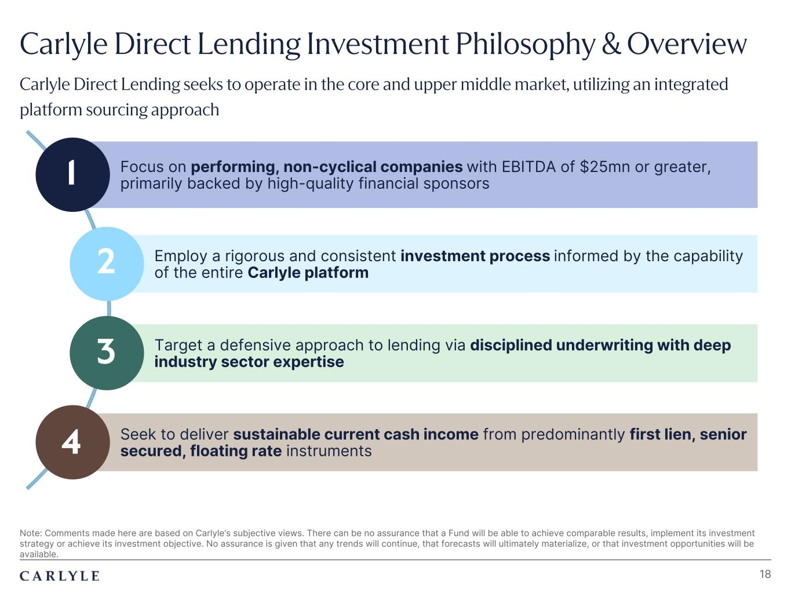
Plum R117 G45 B79 Dark Gray R101 G101 B101 Light Green R216 G240 B221 Pale Blue R221 G244 B255 Light Indigo R176 G188 B228 Indigo R49 G71 B143 Brown R96 G70 B60 Taupe R209 G199 B189 Light Gray R230 G230 B230 Dark Blue R22 G32 B64 Green R57 G108 B101 Champagne R251 G246 B237 Sky Blue R149 G218 B255 Salmon R240 G196 B188 Seek to deliver sustainable current cash income from predominantly first lien, senior secured, floating rate instruments Employ a rigorous and consistent investment process informed by the capability of the entire Carlyle platform Note: Comments made here are based on Carlyle’s subjective views. There can be no assurance that a Fund will be able to achieve comparable results, implement its investment strategy or achieve its investment objective. No assurance is given that any trends will continue, that forecasts will ultimately materialize, or that investment opportunities will be available. 18 Focus on performing, non-cyclical companies with EBITDA of $25mn or greater, primarily backed by high-quality financial sponsors Target a defensive approach to lending via disciplined underwriting with deep industry sector expertise 1 2 3 4 Carlyle Direct Lending Investment Philosophy & Overview Carlyle Direct Lending seeks to operate in the core and upper middle market, utilizing an integrated platform sourcing approach

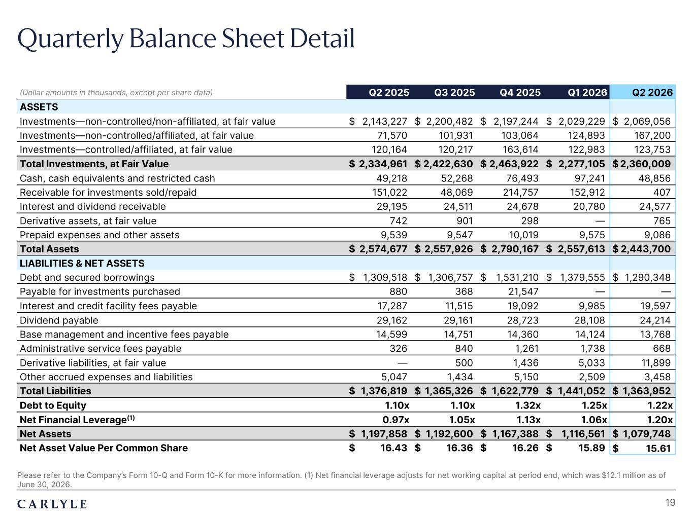
Plum R117 G45 B79 Dark Gray R101 G101 B101 Light Green R216 G240 B221 Pale Blue R221 G244 B255 Light Indigo R176 G188 B228 Indigo R49 G71 B143 Brown R96 G70 B60 Taupe R209 G199 B189 Light Gray R230 G230 B230 Dark Blue R22 G32 B64 Green R57 G108 B101 Champagne R251 G246 B237 Sky Blue R149 G218 B255 Salmon R240 G196 B188 Quarterly Balance Sheet Detail Please refer to the Company’s Form 10-Q and Form 10-K for more information. (1) Net financial leverage adjusts for net working capital at period end, which was $12.1 million as of June 30, 2026. 19 (Dollar amounts in thousands, except per share data) Q2 2025 Q3 2025 Q4 2025 Q1 2026 Q2 2026 ASSETS Investments—non-controlled/non-affiliated, at fair value $ 2,143,227 $ 2,200,482 $ 2,197,244 $ 2,029,229 $ 2,069,056 Investments—non-controlled/affiliated, at fair value 71,570 101,931 103,064 124,893 167,200 Investments—controlled/affiliated, at fair value 120,164 120,217 163,614 122,983 123,753 Total Investments, at Fair Value $ 2,334,961 $ 2,422,630 $ 2,463,922 $ 2,277,105 $ 2,360,009 Cash, cash equivalents and restricted cash 49,218 52,268 76,493 97,241 48,856 Receivable for investments sold/repaid 151,022 48,069 214,757 152,912 407 Interest and dividend receivable 29,195 24,511 24,678 20,780 24,577 Derivative assets, at fair value 742 901 298 — 765 Prepaid expenses and other assets 9,539 9,547 10,019 9,575 9,086 Total Assets $ 2,574,677 $ 2,557,926 $ 2,790,167 $ 2,557,613 $ 2,443,700 LIABILITIES & NET ASSETS Debt and secured borrowings $ 1,309,518 $ 1,306,757 $ 1,531,210 $ 1,379,555 $ 1,290,348 Payable for investments purchased 880 368 21,547 — — Interest and credit facility fees payable 17,287 11,515 19,092 9,985 19,597 Dividend payable 29,162 29,161 28,723 28,108 24,214 Base management and incentive fees payable 14,599 14,751 14,360 14,124 13,768 Administrative service fees payable 326 840 1,261 1,738 668 Derivative liabilities, at fair value — 500 1,436 5,033 11,899 Other accrued expenses and liabilities 5,047 1,434 5,150 2,509 3,458 Total Liabilities $ 1,376,819 $ 1,365,326 $ 1,622,779 $ 1,441,052 $ 1,363,952 Debt to Equity 1.10x 1.10x 1.32x 1.25x 1.22x Net Financial Leverage(1) 0.97x 1.05x 1.13x 1.06x 1.20x Net Assets $ 1,197,858 $ 1,192,600 $ 1,167,388 $ 1,116,561 $ 1,079,748 Net Asset Value Per Common Share $ 16.43 $ 16.36 $ 16.26 $ 15.89 $ 15.61

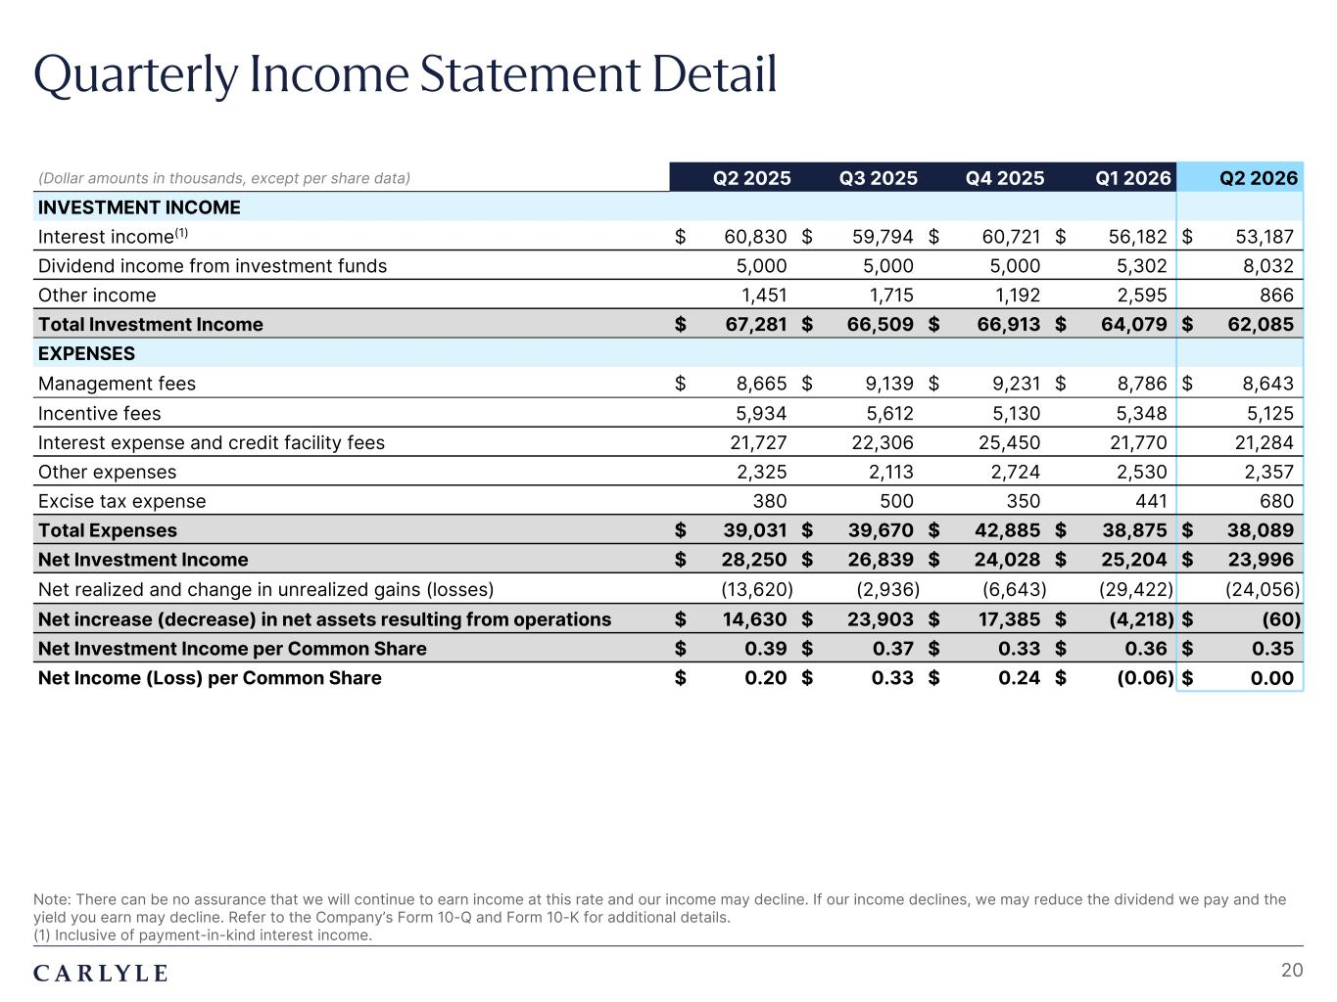
Plum R117 G45 B79 Dark Gray R101 G101 B101 Light Green R216 G240 B221 Pale Blue R221 G244 B255 Light Indigo R176 G188 B228 Indigo R49 G71 B143 Brown R96 G70 B60 Taupe R209 G199 B189 Light Gray R230 G230 B230 Dark Blue R22 G32 B64 Green R57 G108 B101 Champagne R251 G246 B237 Sky Blue R149 G218 B255 Salmon R240 G196 B188 Quarterly Income Statement Detail Note: There can be no assurance that we will continue to earn income at this rate and our income may decline. If our income declines, we may reduce the dividend we pay and the yield you earn may decline. Refer to the Company’s Form 10-Q and Form 10-K for additional details. (1) Inclusive of payment-in-kind interest income. 20 (Dollar amounts in thousands, except per share data) Q2 2025 Q3 2025 Q4 2025 Q1 2026 Q2 2026 INVESTMENT INCOME Interest income(1) $ 60,830 $ 59,794 $ 60,721 $ 56,182 $ 53,187 Dividend income from investment funds 5,000 5,000 5,000 5,302 8,032 Other income 1,451 1,715 1,192 2,595 866 Total Investment Income $ 67,281 $ 66,509 $ 66,913 $ 64,079 $ 62,085 EXPENSES Management fees $ 8,665 $ 9,139 $ 9,231 $ 8,786 $ 8,643 Incentive fees 5,934 5,612 5,130 5,348 5,125 Interest expense and credit facility fees 21,727 22,306 25,450 21,770 21,284 Other expenses 2,325 2,113 2,724 2,530 2,357 Excise tax expense 380 500 350 441 680 Total Expenses $ 39,031 $ 39,670 $ 42,885 $ 38,875 $ 38,089 Net Investment Income $ 28,250 $ 26,839 $ 24,028 $ 25,204 $ 23,996 Net realized and change in unrealized gains (losses) (13,620) (2,936) (6,643) (29,422) (24,056) Net increase (decrease) in net assets resulting from operations $ 14,630 $ 23,903 $ 17,385 $ (4,218) $ (60) Net Investment Income per Common Share $ 0.39 $ 0.37 $ 0.33 $ 0.36 $ 0.35 Net Income (Loss) per Common Share $ 0.20 $ 0.33 $ 0.24 $ (0.06) $ 0.00

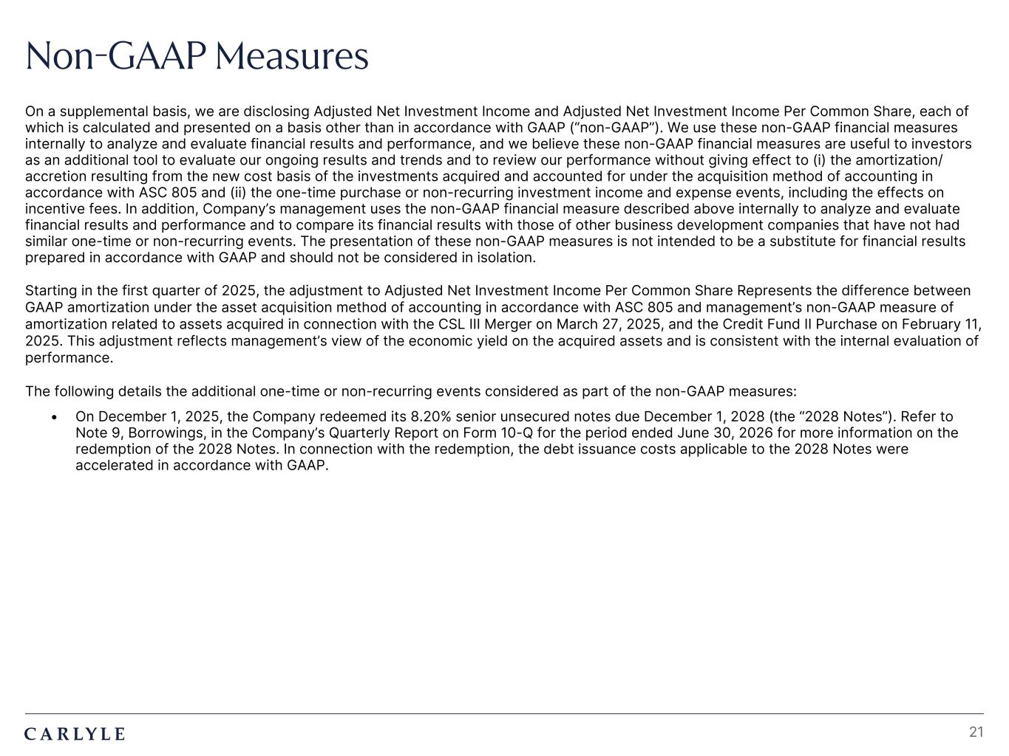
Plum R117 G45 B79 Dark Gray R101 G101 B101 Light Green R216 G240 B221 Pale Blue R221 G244 B255 Light Indigo R176 G188 B228 Indigo R49 G71 B143 Brown R96 G70 B60 Taupe R209 G199 B189 Light Gray R230 G230 B230 Dark Blue R22 G32 B64 Green R57 G108 B101 Champagne R251 G246 B237 Sky Blue R149 G218 B255 Salmon R240 G196 B188 21 Non-GAAP Measures On a supplemental basis, we are disclosing Adjusted Net Investment Income and Adjusted Net Investment Income Per Common Share, each of which is calculated and presented on a basis other than in accordance with GAAP (“non-GAAP”). We use these non-GAAP financial measures internally to analyze and evaluate financial results and performance, and we believe these non-GAAP financial measures are useful to investors as an additional tool to evaluate our ongoing results and trends and to review our performance without giving effect to (i) the amortization/ accretion resulting from the new cost basis of the investments acquired and accounted for under the acquisition method of accounting in accordance with ASC 805 and (ii) the one-time purchase or non-recurring investment income and expense events, including the effects on incentive fees. In addition, Company’s management uses the non-GAAP financial measure described above internally to analyze and evaluate financial results and performance and to compare its financial results with those of other business development companies that have not had similar one-time or non-recurring events. The presentation of these non-GAAP measures is not intended to be a substitute for financial results prepared in accordance with GAAP and should not be considered in isolation. Starting in the first quarter of 2025, the adjustment to Adjusted Net Investment Income Per Common Share Represents the difference between GAAP amortization under the asset acquisition method of accounting in accordance with ASC 805 and management’s non-GAAP measure of amortization related to assets acquired in connection with the CSL III Merger on March 27, 2025, and the Credit Fund II Purchase on February 11, 2025. This adjustment reflects management’s view of the economic yield on the acquired assets and is consistent with the internal evaluation of performance. The following details the additional one-time or non-recurring events considered as part of the non-GAAP measures: • On December 1, 2025, the Company redeemed its 8.20% senior unsecured notes due December 1, 2028 (the “2028 Notes”). Refer to Note 9, Borrowings, in the Company’s Quarterly Report on Form 10-Q for the period ended June 30, 2026 for more information on the redemption of the 2028 Notes. In connection with the redemption, the debt issuance costs applicable to the 2028 Notes were accelerated in accordance with GAAP.

